*******OUTREACH NOTICE*******
WAYNE NATIONAL FOREST
Support Services Specialist, GS-0342-6/7

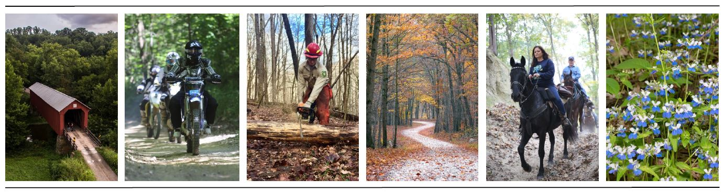
POSITION INFO
Title, Series, and Grade: Support Services Specialist, GS-0342-6/7
Position: One (1)
Tour of Duty: Detail Temporary promotion-NTE 120 days – Full -Time Position
Duty Station: Wayne National Forest, Athens Ranger District, Nelsonville OH.

MAJOR DUTIES:
Serves as the point of contact involving unit project proposals by collecting and analyzing costs, staff power and procurement. Reviews project expenditures by ensuring allocations are not exceeded and surpluses are identified, appropriate staffs are alerted, and if necessary, recommends reprogramming in other areas. Initiates and controls a variety of personnel processing activities, e.g., initiating electronic requests for personnel actions, annual performance ratings, local recruitment, and new employee orientation. Ensures staff maintains employee development folders for employees. Advises the supervisors of cyclical actions for which employees are about to become eligible. Prepares and monitors human resources-related reports for the office.
Keeps employees informed of human resources policy and regulatory changes, such as those related to leave, injury compensation, retirement, promotion, etc. Assist District/Forest staff in the use of Paycheck 8 and ensures that staff is kept current on HR policies, rules, and regulations regarding time and attendance, office closure, etc. Responsible for purchasing or contracting for supplies, equipment, and services through open market purchase by blanket arrangement, cash, or field purchase order using a VISA credit card. Prepares documents to order goods, supplies and/or services for various unit operations. Responsible for selecting the correct and most cost-efficient method and/or instrument to accomplish procurement action. Advises staff on availability of funds and impact pending procurement action will have on operating budget when significant.
Ensures that procurement requests for general support services such as office supply stock levels and office equipment include pertinent information such as item description, quantity, discount terms, unit prices, delivery terms, fund citation, special clauses, and certifications. Verifies purchase order receipts and follows up on invoices and other payment documents. Prepares, controls, coordinates, and assembles information for procurement documents. Reviews contract status reports to determine which purchase orders, inter-agency agreements, or contracts are active or inactive.

Position Contact – Further Information:

For further information please contact Jason Reed, Athens District Ranger, at jason.reed@usda.gov or
740-753-0403.

Outreach Response Database:
Forest Service Internal: https://apps.fs.usda.gov/hrm/outreach/Outreach?id=B49DA719298249A390080E80E5D3FDBC

Public Link: https://fsoutreach.gdcii.com?id=B49DA719298249A390080E80E5D3FDBC

Responding to our outreach database provides us your contact information so that we may inform you when the vacancy is open in USA Jobs. To respond using the Outreach Database, please click the link below and respond. Thank you.

About the Forest:

The Wayne National Forest, located in the hills of southeastern Ohio, encompasses approximately 244,000 acres across 12 counties. The Wayne is divided into three units (Athens, Marietta, and Ironton) administered by two Ranger Districts at Athens and Ironton. A field office is also located east of Marietta.

The Forest consists predominantly of oak/hickory and mixed hardwood forests with smaller amounts of pine in the unglaciated foothills of the Appalachian Mountains. Several smaller rivers and the much larger Ohio River are located within the Forest providing some of the best warm water fishing in the state. The Wayne National Forest was also recently rated as one of the top 10 public land hunting opportunities in the country and is known for producing large white-tailed bucks.
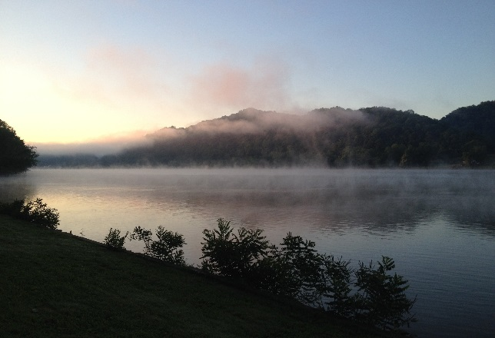
The Wayne gives visitors a chance to explore southeastern Ohio’s diverse landscape of hills, valleys, streams and rivers. Visitors are welcome to camp, hike, hunt and fish. With over 400 miles of trail for hiking, all-terrain vehicle (ATV) riding, mountain biking, and horseback riding, trail opportunities are wide-ranging. Additionally, the Wayne attracts visitors that range from medicinal root hunters and deer hunters to backpackers in an area where they can hike and camp on public land that is limited in Ohio.

The Forest boundaries surround a checkerboard pattern of ownership, with public and private ownership interspersed. As arguably one of the most complex landscapes to manage due to the urban to rural gradient, overlapping ownership issues, and diversity of public opinion, working on this Forest will provide one with a knowledge and skillset that will advance one’s career in natural resource management, as well as the support of a friendly, welcoming work environment.

More information about the Forest can be found on our websites:
WNF internet site (www.fs.usda.gov/wayne)
www.facebook.com/WayneNationalForest
www.twitter.com/WayneNationalFS

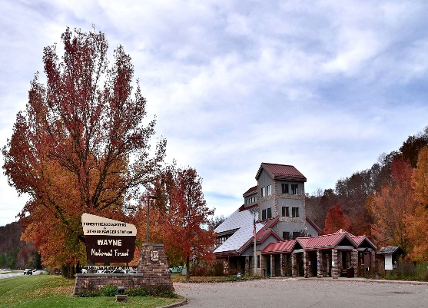
About the Wayne National Forest Supervisors Office and Community:

The Supervisor’s Office and Athens Ranger District are co-located outside of Athens, Ohio, which is the home of Ohio University with over 24,000 students. The Athens Ranger Station-Athens Unit office manages more than 72,000 acres of the Wayne National Forest located in southeast Ohio. Communities nearest the Athens Unit include Athens, Nelsonville, Chauncey, and New Straitsville.

Athens is the cultural hub of southeast Ohio providing access to arts, music, entertainment, and commerce associated with a university. Visitors to the area can enjoy local breweries and eateries, movie theatres, farmers markets, and numerous street festivals. Sports fans can enjoy Division 1 athletic events at Ohio University, as well as the Copperheads minor league baseball team. Several full service communities, such as Nelsonville, Logan, and Albany are within commuting distance and offer a variety of options for housing and a range of services.

Public schools and medical services are abundant. The cost of living is very reasonable with many housing options available in all price ranges. The climate is hot and humid in the summer and relatively mild winters with occasional ground covering snowfall. Spring brings an explosion of new growth, with fall ushering forth the wonderful hardwood color change.

Tourism is a large and growing component of the Athens County economy. Thousands of people all over the country visit to enjoy the scenic views and nature within the area. The county is a regional music center and home to many arts and crafts businesses. Many visitors to the county are drawn to its natural resources and abundant wildlife. Hunting and fishing are popular activities in season. Another favorite among those in the community, Athens County has over 19 miles of paved bike path in and between Athens and Nelsonville. With neighboring parks and forests, including the popular Hocking Hills State Park and Forest, outdoor adventures expand to other areas within a short commute from Athens County

The nearest major city from Athens County is Columbus, Ohio. However, other major cities such as Cincinnati, Louisville, Pittsburgh, Cleveland, and Charleston are all within a three-hour drive from Athens County. Within 8 hours, you can access Washington, D.C., Chicago, or Nashville.

SCHOOLS: There are five school districts serving Athens County: the Alexander Local School District, Athens City School District, the Federal Hocking Local School District, Nelsonville-York City School District, and the Trimble Local School District. Altogether, there are 6 high schools, 4 middle schools, 10 elementary schools, and 4 pre-k.

Hocking College and Ohio University serve as the two higher education institutions in the county. Over one-fourth of the county residents either work at or attend these institutions.

HEALTH CARE: O'Bleness Memorial Hospital located in Athens, Ohio, is the primary full-service hospital in the county. There are also other clinics and urgent care services within Athens County.

TRAVEL: The nearest airport to Athens County is the John Glenn Columbus International Airport located 80 miles north in Columbus, Ohio.

WEATHER: Winters are cool to cold with mild periods and summers are generally hot and humid, with significant precipitation year-round. July is the warmest month with an average high of 85 degrees Fahrenheit. January is the coolest month with an average low of 22 degrees Fahrenheit. The average annual precipitation is about 43 inches and an average annual snowfall of about 20 inches. The month of January usually receives the most snowfall with an average of 7 inches, but usually melts pretty quickly.

HOUSING: The median home value in Athens, Ohio, is $153,900. Average rent for a 2 bedroom is $727, but can range anywhere from $600 to $1600.

ANNUAL EVENTS: The Athens Farmers Market, an outdoor market, continues to grow in popularity. Local and organically grown produce is found in abundance during the summer months. There is also the
Pawpaw Festival, Ohio Beer Week (Athens, July), Halloween Festival (Athens, October), Nelsonville Music Festival (Nelsonville, May/June), and Boogie on the Bricks (Athens, June).
For additional information on the Nelsonville/Athens area see:
http://athenschamber.com/
http://www.nelsonvillechamber.com/
http://athensohio.com/

