Shawnee National Forest

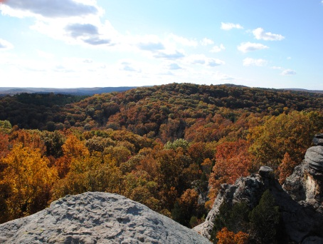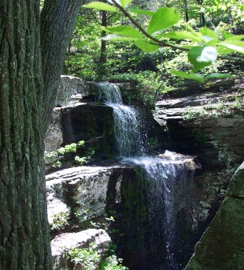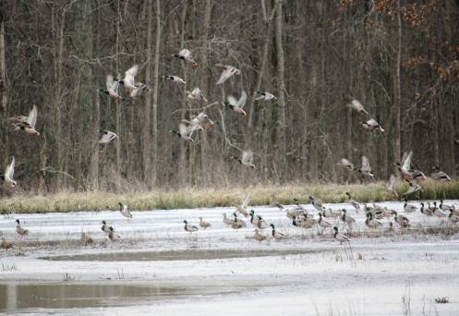

“Caring for the Land and Serving People”

Environmental Coordinator

Permanent Full Time

Harrisburg, IL

GS-0101/0401/1301-12

The Shawnee National Forest (Forest) is advertising a permanent, full-time GS-0101/0401-12 Environmental Coordinator position. This position is located on a National Forest Supervisor’s Office in Harrisburg, Illinois and serves as the NEPA/Appeals & Litigation coordinator for NEPA, CEQ, NFMA, FOIA, and Appeals and Litigation.
For additional details on the position, you may call Justin Dodson at 618-658-1316 or email justin.dodson@usda.gov.

If you are interested in this position, please return the attached Outreach Response Form and full resume by the close of business on September 22, 2022.

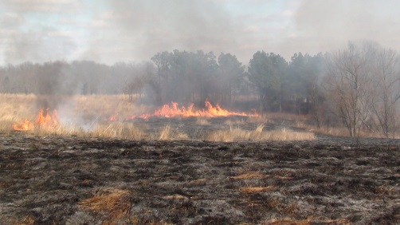
Summary of the Position:

This non-supervisory position is responsible for planning, directing and advising Forest personnel on compliance efforts regarding National Environmental Policy Act (NEPA), regulations of the President’s Council on Environmental Quality (CEQ), the National Forest Management Act (NFMA), the Forest Plan, and Forest Service Policy.

The incumbent is expected to be a subject matter expert providing the Forest’s Line Officers and Staff Officers with advice and interpretation of a broad range of environmental policies.

Provide Program Managers and district NEPA Coordinators with technical leadership and guidance concerning the interpretation and implementation of environmental policies.

Responsible for mediating conflicting viewpoints of Interdisciplinary Team (IDT) members on preparation and processing of Categorical Exclusions and Environmental Assessments.

In coordination with the Regional Office, serves as the final authority of environmental documents for compliance with NEPA, CEQ, NFMA, FOIA and guides each of the subsequent objection and/or litigation reviews.

Executes and coordinates final evaluation and review of environmental analysis documents for Forest projects and/or programs to ensure compliance with multiple environmental policy requirements. Ensures all Forest projects are consistent with law, regulation and policy.

Identifies the need for and type(s) of environmental policy training for Forest personnel involved in NEPA, CEQ, NFMA, FOIA and Appeals and Litigation reviews, projects, requests and responses.

Interprets and disseminates changes, decision, and direction regarding all environmental policies that would affect the Forest. Communicates the impacts and applicability of changes, decisions, and directions to Forest Line Officers and Staff involved in projects and/or programs that are subject to NEPA, CEQ, NFMA, FOIA and Appeals and Litigation.

Description of the Forest:

The Shawnee National Forest includes about 280,000 acres of National Forest System land and is the single largest publicly owned body of land in the State of Illinois. Within those lands, one can find the following:
- Seven Congressionally-designated Wilderness Areas (about 10% of the Forest)
- Six candidate Wild and Scenic Rivers
- Four National Natural Landmarks
- Four heritage resource sites on the National Register of Historic Places
- Two National Scenic Byways (NSB)
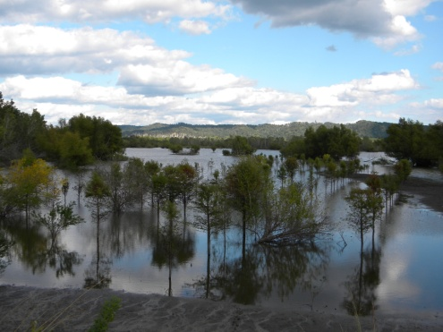
  - Great River Road NSB, extending along the Mississippi River
  - Ohio River NSB, along the Ohio, where it begins in Pennsylvania, traveling to Cairo, Illinois, where the Ohio meets the mighty Mississippi
- 80 designated Natural Areas considered important for botanical, ecological, geological or zoological reasons (about 5% of the Forest). Ten of these natural areas are designated by the Forest Service as Research Natural Areas (9 ecological areas and 1 botanical area) to focus research on these high value ecological sites.
  - 56 ecological areas
  - 14 botanical areas
  - 3 geological areas
  - 7 zoological areas
The Forest sits at the confluence of the Mississippi and Ohio Rivers and is rich in history, reflecting the pioneer movement of Americans into the west. Although predominantly oak-hickory, pine was planted in many areas in the past. Swamps contain tupelo and cypress communities. Razorback ridges associated with the Ozark up thrust are found on the west side of the Forest; the broader ridges associated with the Shawnee hills are found on the east side of the Forest. The Wisconsin glacier stopped north of the Shawnee, so the Grand Prairie (and its corn fields) most associated with the state of Illinois starts 40 miles north of the Forest.

The Shawnee is located within a day's drive (350 miles) of more than 45 million people, or 17% of the U.S. population (U.S. Census Bureau, 7-1-97 estimate). Additional information about the Forest may be found at the Shawnee National Forest website.
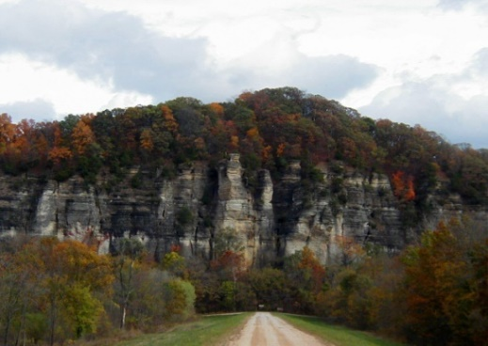
Climate:

One can experience all four seasons in the southern Illinois region with an average of 3” of snow per year and temperatures rarely below 0 degrees. Summer days are sunny and humid with highs in the 80’s – 90’s, occasionally topping 100. Spring weather can occur in March, and fall weather can extend into November. During the spring and fall seasons, the climate and beauty of the area is especially compelling. Spring brings an abundance of blooming dogwoods, redbuds and wildflowers.

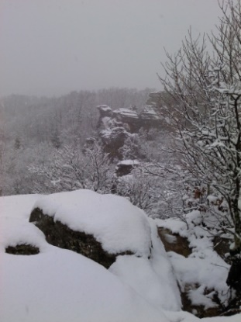
The fall is saturated with color, as the leaves turn brilliant reds, gold and yellows. Garden of the Gods, the most visited site on the Forest, is a must-see during the fall color season. The unusual rock formations, coupled with the surrounding Garden of the Gods Wilderness, portray the beauty of southern Illinois at its finest.

Education:
Pre-schools through high schools can be found in most communities and rank high in the state. There are several community colleges in the area offering quite reasonable in-district tuition. Southern Illinois University, located in Carbondale, IL, offers a full range of baccalaureate through doctoral programs. Day care facilities also are available in most communities.

Houses of Worship:

Houses of Worship representing all major faiths can be found in communities across the region.

Economy:

Real estate in the area is moderately priced. The median price for purchasing a home is approximately $120,000, and house rentals begin at approximately $450 per month. Utilities are also priced moderately. Tourism is a developing economic force in the area. In recent years, several wineries have opened, offering two outstanding wine trails. Local breweries are also starting to emerge, adding to the tourism opportunities in the region.
With a mix of communities and towns, varying in population, Southern Illinois offers a rural environment with easy access to all possible amenities. Both shopping and entertainment opportunities are abundant within the area. Marion and Carbondale, IL along with Paducah, KY, offer shopping malls, movie theaters and several locally owned and operated restaurants along with major chain and fast-food restaurants. Additional information on local employment opportunities can be found at the following links:

Harrisburg, IL – Companies and Businesses
Marion, IL – Companies and Businesses
Carbondale, IL – Companies and Business

Jonesboro, IL – Companies and Business

Healthcare:

Healthcare facilities serving the area include full facility Harrisburg Medical Center (Hospital), Carbondale Doctor’s Memorial Hospital and Marion Memorial Hospital. Services at these hospitals include cardiac units, oncology and neonatal units. Other hospitals providing care are Lourdes and Western Baptist Hospital in Paducah, KY and Deaconess in Evansville, IN. All the hospitals provide 24-hour emergency room physician coverage and specialists.

Recreational and Cultural Activities:

Whether you’re a barbecue fan, blues lover, outdoor recreational enthusiast, lover of small town life or big city adventurer, southern Illinois truly provides something for everyone in terms of social engagement opportunities and overall choice of recreational/cultural type activities.
With the perfect mix of small to mid-sized towns across the region coupled with easy access to bigger cities, including St. Louis, MO (located about 2 hours from Harrisburg, IL), Nashville, TN (located about 2.5 hours from Harrisburg, IL) and Chicago, IL (located about 6 hours from Harrisburg, IL), residents will find the ability to immerse themselves in the rich cultural and natural heritage encompassed in the area while also being able to easily travel and explore larger metropolitan areas nearby.
Festivals, fairs, artisan type craft events and more abound annually, and from more traditional American fare to Cuban, Thai, Japanese and more, a variety of restaurants representing global cuisine choices can be found across the region. Other opportunities, including concerts, theater engagements, etc, can also be discovered at a variety of events and locations, offering easy access to diverse recreational and cultural activities while also offering a beautiful, predominantly agricultural based area to call home.
To learn more about the area, please visit the following:
Marion, IL Chamber of Commerce
Saline County, IL Chamber of Commerce
Saline County, IL Tourism
Southernmost Illinois Tourism Bureau
Williamson County, IL Tourism Bureau

Union County, IL Tourism Bureau

Non-Discrimination Statement
In accordance with Federal civil rights law and U.S. Department of Agriculture (USDA) civil rights regulations and policies, the USDA, its Agencies, offices, and employees, and institutions participating in or administering USDA programs are prohibited from discriminating based on race, color, national origin, religion, sex, gender identity (including gender expression), sexual orientation, disability, age, marital status, family/parental status, income derived from a public assistance program, political beliefs, or reprisal or retaliation for prior civil rights activity, in any program or activity conducted or funded by USDA (not all bases apply to all programs). Remedies and complaint filing deadlines vary by program or incident.
Persons with disabilities who require alternative means of communication for program information (e.g., Braille, large print, audiotape, American Sign Language, etc.) should contact the responsible Agency or USDA’s TARGET Center at (202) 720-2600 (voice and TTY) or contact USDA through the Federal Relay Service at (800) 877-8339. Additionally, program information may be made available in languages other than English.
To file a program discrimination complaint, complete the USDA Program Discrimination Complaint Form, AD-3027, found online at http://www.ascr.usda.gov/complaint_filing_cust.html and at any USDA office or write a letter addressed to USDA and provide in the letter all of the information requested in the form. To request a copy of the complaint form, call (866) 632-9992. Submit your completed form or letter to USDA by: (1) mail: U.S. Department of Agriculture, Office of the Assistant Secretary for Civil Rights, 1400 Independence Avenue, SW, Washington, D.C. 20250-9410; (2) fax: (202) 690-7442; or (3) email: program.intake@usda.gov.

Outreach Response Form
Environmental Coordinator, GS-0101/0401/1301-12, Permanent Full Time
Harrisburg, IL
Please submit outreach response and resume by September 22, 2022
Justin Dodson, justin.dodson@usda.gov

Name:

Email Address:

Mailing Address:

Telephone Number:

Current Employer:

Current Region/Forest/District:

Type of Appointment:

Series and Grade (If Usfs):

Current Position Title:

How Did You Hear About This Opportunity?

If not a current permanent (career or career-conditional) employee, are you eligible to be rehired under any of the following special authorities?

persons with disabilities

veterans recruitment Act

disabled veterans with 30% compensable disability

veterans employment opportunities act of 1998

former peace corps volunteer

Pathways Students Program

other:

Thank you for your interest in our vacancy!

USDA Forest Service is an equal opportunity provider and employer.

