Hoosier and Shawnee National Forest
OUTREACH NOTICE

Non-competitive Detail or Promotional Detail
Information Specialist (GIS), GS-0101/0401/1301-11
Expected start date April 2022
-and-
Permanent Position
The Permanent Position may be advertised as a GS-11 or GS-11/12

Multiple Duty Locations Available:
Tell City, IN
Bedford, IN
Harrisburg, IL

This outreach will inform how the permanent position may be advertised.

A RESUME IS REQUIRED. If you are interested, please send the below outreach form and a copy of your resume to Lisa Helmig (lisa.helmig@usda.gov) no later than March 18th, 2022.

Virtual Duty Station may be considered for Detail
Permanent position is NOT 100% Telework.
The Shawnee is a bargaining unit location. The Hoosier is not a bargaining unit location.

Zoned Position
This position oversees the GIS zone which provides geospatial guidance, leadership, and integrated support for product and spatial data management to all program areas on the Hoosier and Shawnee National Forests.

Major Duties (but not limited to)
Data Management
- Works with managers and resource specialists to determine type, amount and level of information required to develop and analyze ecosystem management alternatives.
- Assesses quality, compatibility, and limitations of various data used in a wide array of land management and planning efforts.
- Develops data dictionaries, data models, and metadata for multi-disciplinary information and geospatial applications. Coordinates conversion of geospatial information and remote sensing imagery into GIS databases. Responsible for organization and maintenance of resource information and data to facilitate analysis across multiple disciplines including but not limited to recreation, silviculture, planning, engineering and fire.
Geospatial Analysis
- Provides expertise and makes recommendations on the development and application of geospatial analysis processes, protocols and solutions to mission critical resource management issues.
Cartography/Map design and production
- Compiles natural resource, topographic, and cartographic data for creation of thematic map products and presentation materials for multi-disciplinary resource management planning, preparation of environmental and social assessments, environmental impact statements and other projects supporting natural resource management decision making.
Program Liaison
- Technical point of contact with the Regional Office, Federal, State, and local governments; learning institutions; the private sector; professional organizations; and other individuals concerned with GIS, GPS, remote sensing, and mapping.
Training and Support
- Conducts formal and informal training and provides technical assistance to GIS software users in the development, storage, retrieval, and analysis of data.

Position serves as the Supervisor for the three zoned GIS employees on the Shawnee and Hoosier National Forests.

Description of the Forests
The Hoosier National Forest encompasses nearly 204,000 acres in South Central Indiana stretching south from Bloomington to the Ohio River and is located within a drive of two hours or less from Cincinnati, Ohio; Evansville and Indianapolis, Indiana; and Louisville, Kentucky. Two ranger districts include the Brownstown District in Bedford, Indiana and the Tell City District in Tell City, Indiana.
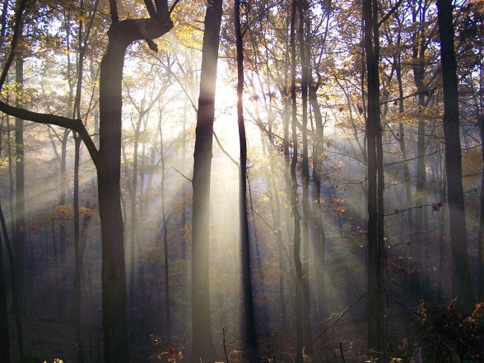
The Hoosier National Forest sits in the unglaciated hills of Southern Indiana. The Forest provides a range of opportunities and resources for people to enjoy. The many recreation opportunities including camping, fishing, hiking, horseback riding, hunting, mountain bike riding, and viewing scenery. The only congressionally designated wilderness in Indiana, the 13,000 acre Charles C. Deam Wilderness provides opportunities for users desiring higher levels of solitude. In addition the Forest has over 265 miles of trails for hiking, biking, or horseback riding.
The Hoosier works to provide integrated resource management on the complex mosaic that make up National Forest System Lands in Indiana. Only 31% of the land within the Forest Boundary is National Forest System land, this scattered ownership pattern adds a complexity to the management of this valued natural resource. Forest managers are responsible for protection of some very unique resources. The Hoosier is located in an area rich in caves and karst features. These underground features are largely unknown to most Forest visitors but are home to many species that are specific to these habitats. The Hoosier has six endangered or threatened species: the fanshell, rough pigtoe, and sheepnose mussels reside in rivers to the south; the gray, Indiana and northern long-eared bats and their habitat occur throughout the Forest. The wildlife program on the Forest focuses on management to provide habitat for these species as well as many others that occur throughout the area.
The Forest works to maintain and restore sustainable ecosystems. The vegetation management on the forest focuses on promoting native oak and hickory regeneration, reducing nonnative pine planted to restore over farmed lands, and reducing nonnative invasive plant and animal species.
The Hoosier National Forest organization is non-traditional with an emphasis on placing resource specialists closer to the ground. Certain Forest-level staff functions that traditionally reside in a Supervisor’s Office work in a team environment and serve as District-level program managers. This serves to broaden District interdisciplinary teams and improve technology transfer, customer service, and quality of stewardship. We view the Districts as the backbone of the Forest Service organization and emphasize customer service at that level. Additional information and an orientation video of the Forest may be found Hoosier National Forest.

Bedford, IN.
The Hoosier National Forest Supervisor’s Office is co-located within the Brownstown Ranger District in Bedford, Indiana. Bedford is a full-service community of approximately 14,000 residents. Bedford has excellent schools, outstanding shopping, cultural amenities, and small town atmosphere. Bedford is in the Eastern Time zone and features a broad-based economy. Major area employers include GM Powertrain, Indiana Limestone, Manchester Tank, and Stone City Products. Bedford is known as the “Limestone Capital of the World” because of the abundance and quality of the limestone which has been used on many landmark buildings in the U.S., including the Empire State Building and the Pentagon.
Bedford has five elementary schools, one junior high school, one high school (includes area vocational school) and Bedford City College, which offers adult education and college credit courses. Eighteen miles north of Bedford is Bloomington, home of Indiana University. In addition, Bedford is within commuting distance of six degree granting institutions. Indianapolis is approximately 70 miles north and is the state capitol.
Housing prices, for purchase or rent, are reasonable and affordable. Local services include a wide variety of places of worship, a library, two hospitals providing comprehensive medical services, and a variety of banking, shopping facilities, and restaurants.
There are several communities within commuting distance of Bedford. Links are provided below:
Bedford, Indiana; Bloomington, Indiana; Mitchell, Indiana; Seymour, Indiana

Tell City Office
The Hoosier National Forest Tell City Ranger District Office is in Tell City and Perry County. Tell City is located on the banks of the Ohio River and was founded in 1858 by the Swiss Colonization Society for Swiss and German immigrants. Settlement occurred early due to the city’s proximity to the Ohio River. Community development was directly related to river travel. The city recognizes it’s Swiss and German heritage each August at the annual Schweizer Fest. Perry County has a population of approximately 18,900 people, with an estimated 7,500 in Tell City. The area observes central time zone.
Major industries in the area include lumbering, manufacturing, and farming, additional area employers include ThyssenKrupp Waupaca, Mulzer Crushed Stone, Accent Marketing Services, ATTC Manufacturing, and Branchville Correctional Facility.

Perry County has 3 public elementary schools (1 in Tell City); 3 junior –senior high schools (7-12) (1 in Tell City). In addition, there are two private schools located in the county. Perry County also boasts a state community college campus (Ivy Tech). Perry County Hospital is located between the communities of Tell City and Cannelton. Housing in Perry County is very affordable. Median home values in Tell City are around $87,000.

Perry County’s rolling hills along the Ohio River provide amazing views of natural beauty, the area is well suited to outdoor recreation pursuits. Several boat ramps on the Ohio River provide access for boating and fishing. Five man-made lakes in Perry County offer water-based recreation opportunities.
The Ohio River National Scenic Byway runs through the county providing scenic bicycling and driving areas that tell the story of the river, the county, and the culture of the area.

Find more information about the Tell City area by visiting http://www.perrycountyindiana.org.
The following link contains videos highlighting the quality of life and schools in Perry County: http://www.pickperry.com/videos.html.

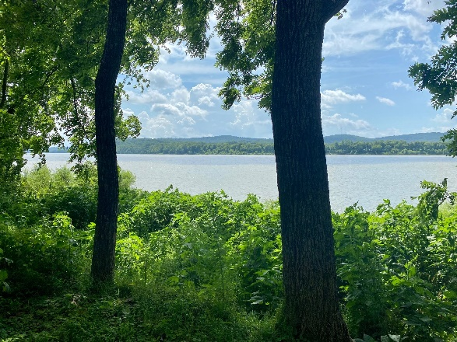
Climate:
The temperature in southern Indiana varies north to south. Although Indiana sometimes has temperatures below zero during the winter, the average temperatures in January range between 17°F and 35°F. Rainfall is distributed evenly throughout the year. The average annual precipitation statewide is 40 in, ranging from about 35 in (89 cm) near Lake Michigan to 45 inches along the Ohio River; from, 1981 - 2010, Indianapolis had an average of 42 inches annually. The annual snowfall averages about 26 inches.
Places of Worship:
Churches representing all major denominations; as well as Jewish, Islamic, Buddhist and other places of worship; can be found in communities across the area.
Economy:
Real estate in the area is moderately priced, as are utilities. Tourism is a developing economic force in the area. In recent years, several wineries and craft breweries have opened, adding to the tourism opportunities in the region.
Healthcare:
Healthcare facilities serving the area include full facility IU Health Bedford Hospital and St. Vincent Dunn Hospital, in Bedford, along with full service hospitals and medical practices in Bloomington. Services at these hospitals include cardiac units, oncology and neonatal units. Other hospitals providing care in the general area of the Hoosier include Perry County Memorial in Tell City, Indiana; Deaconess in Evansville, Indiana; and University of Louisville Hospital in Louisville, Kentucky. All the hospitals provide 24-hour emergency room physician coverage and specialists.
Recreational and Cultural Activities:
The region has many opportunities for outdoor activities as well as small town festivals and fairs. In addition, there is easy access to larger cities including Cincinnati, Ohio; Chicago, Illinois; Indianapolis, Indiana; Louisville, Kentucky; Nashville, Tennessee; and St. Louis, Missouri.

The Shawnee National Forest includes about 280,000 acres of National Forest System land and is the single largest publicly owned body of land in the State of Illinois. Within those lands, one can find the following:
- Seven Congressionally designated Wilderness Areas (about 10% of the Forest)
- Six candidate Wild and Scenic Rivers
- Four National Natural Landmarks
- Four heritage resource sites on the National Register of Historic Places
- Two National Scenic Byways (NSB)
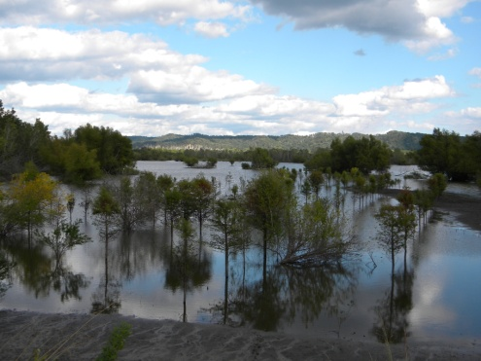
- Great River Road NSB, extending along the Mississippi River
- Ohio River NSB, along the Ohio, where it begins in Pennsylvania, traveling to Cairo, Illinois, where the Ohio meets the mighty Mississippi
- 80 designated Natural Areas considered important for botanical, ecological, geological, or zoological reasons (about 5% of the Forest). Ten of these natural areas are designated by the Forest Service as Research Natural Areas (9 ecological areas and 1 botanical area) to focus research on these high value ecological sites.
  - 56 ecological areas
  - 14 botanical areas
  - 3 geological areas
  - 7 zoological areas

Additional information about the Forest may be found at the Shawnee National Forest website.
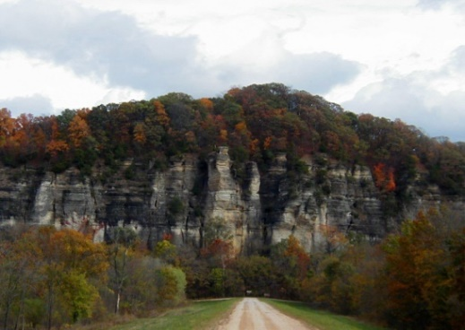
Climate:
One can experience all four seasons in the southern Illinois region with an average of 3” of snow per year and temperatures rarely below 0 degrees. Summer days are sunny and humid with highs in the 80’s – 90’s, occasionally topping 100. Spring weather can occur in March, and fall weather can extend into November. During the spring and fall seasons, the climate and beauty of the area is especially compelling. Spring brings an abundance of blooming dogwoods, redbuds and wildflowers.
The fall is saturated with color, as the leaves turn brilliant reds, gold and yellows. Garden of the Gods, the most visited site on the Forest, is a must-see during the fall color season. The unusual rock formations, coupled with the surrounding Garden of the Gods Wilderness, portray the beauty of southern Illinois at its finest.

Education:
Pre-schools through high schools can be found in most communities and rank high in the state. There are several community colleges in the area offering quite reasonable in-district tuition. Southern Illinois University, located in Carbondale, IL, offers a full range of baccalaureate through doctoral programs. Day care facilities also are available in most communities.

Houses of Worship:
Houses of Worship representing all major faiths can be found in communities across the region.

Economy:
Real estate in the area is moderately priced. The median price for purchasing a home is approximately $120,000, and house rentals begin at approximately $450 per month. Utilities are also priced moderately. Tourism is a developing economic force in the area. In recent years, several wineries have opened, offering two outstanding wine trails. Local breweries are also starting to emerge, adding to the tourism opportunities in the region.
With a mix of communities and towns, varying in population, Southern Illinois offers a rural environment with easy access to all possible amenities. Both shopping and entertainment opportunities are abundant within the area. Marion and Carbondale, IL along with Paducah, KY, offer shopping malls, movie theaters and several locally owned and operated restaurants along with major chain and fast-food restaurants. Additional information on local employment opportunities can be found at the following links:
Harrisburg, IL – Companies and Businesses
Marion, IL – Companies and Businesses
Carbondale, IL – Companies and Business

Jonesboro, IL – Companies and Business

Healthcare:
Healthcare facilities serving the area include full facility Harrisburg Medical Center (Hospital), Carbondale Doctor’s Memorial Hospital and Marion Memorial Hospital. Services at these hospitals include cardiac units, oncology and neonatal units. Other hospitals providing care are Lourdes and Western Baptist Hospital in Paducah, KY and Deaconess in Evansville, IN. All the hospitals provide 24-hour emergency room physician coverage and specialists.

Recreational and Cultural Activities:
Whether you’re a barbecue fan, blues lover, outdoor recreational enthusiast, lover of small town life or big city adventurer, southern Illinois truly provides something for everyone in terms of social engagement opportunities and overall choice of recreational/cultural type activities.
With the perfect mix of small to mid-sized towns across the region coupled with easy access to bigger cities, including St. Louis, MO (located about 2 hours from Harrisburg, IL), Nashville, TN (located about 2.5 hours from Harrisburg, IL) and Chicago, IL (located about 6 hours from Harrisburg, IL), residents will find the ability to immerse themselves in the rich cultural and natural heritage encompassed in the area while also being able to easily travel and explore larger metropolitan areas nearby.
Festivals, fairs, artisan type craft events and more abound annually, and from more traditional American fare to Cuban, Thai, Japanese and more, a variety of restaurants representing global cuisine choices can be found across the region. Other opportunities, including concerts, theater engagements, etc, can also be discovered at a variety of events and locations, offering easy access to diverse recreational and cultural activities while also offering a beautiful, predominantly agricultural based area to call home.
To learn more about the area, please visit the following:
Marion, IL Chamber of Commerce
Saline County, IL Chamber of Commerce
Southernmost Illinois Tourism Bureau
Williamson County, IL Tourism Bureau

Non-Discrimination Statement
In accordance with Federal civil rights law and U.S. Department of Agriculture (USDA) civil rights regulations and policies, the USDA, its Agencies, offices, and employees, and institutions participating in or administering USDA programs are prohibited from discriminating based on race, color, national origin, religion, sex, gender identity (including gender expression), sexual orientation, disability, age, marital status, family/parental status, income derived from a public assistance program, political beliefs, or reprisal or retaliation for prior civil rights activity, in any program or activity conducted or funded by USDA (not all bases apply to all programs). Remedies and complaint filing deadlines vary by program or incident.
Persons with disabilities who require alternative means of communication for program information (e.g., Braille, large print, audiotape, American Sign Language, etc.) should contact the responsible Agency or USDA’s TARGET Center at (202) 720-2600 (voice and TTY) or contact USDA through the Federal Relay Service at (800) 877-8339. Additionally, program information may be made available in languages other than English.
To file a program discrimination complaint, complete the USDA Program Discrimination Complaint Form, AD-3027, found online at http://www.ascr.usda.gov/complaint_filing_cust.html and at any USDA office or write a letter addressed to USDA and provide in the letter all of the information requested in the form. To request a copy of the complaint form, call (866) 632-9992. Submit your completed form or letter to USDA by: (1) mail: U.S. Department of Agriculture, Office of the Assistant Secretary for Civil Rights, 1400 Independence Avenue, SW, Washington, D.C. 20250-9410; (2) fax: (202) 690-7442; or (3) email: program.intake@usda.gov.

HOOSIER and SHAWNEE NATIONAL FOREST

Outreach Response Form
ZONED, INFORMATION MANAGEMENT SPECIALIST (GIS)
Detail: GS-0301/0401/1301-11
Permanent Position: GS-0301/0401/1301-11 or 11/12
Tell City, IN, Bedford, IN, Harrisburg, IL
Please submit outreach response and resume by March 18, 2022
Lisa Helmig, lisa.helmig@usda.gov

Name:

Email Address:

Mailing Address:

Telephone Number:

Current Employer:

Current Region/Forest/District:

Type of Appointment:

Series and Grade (If Usfs):

Current Position Title:

How Did You Hear About This Opportunity?

If not a current permanent (career or career-conditional) employee, are you eligible to be rehired under any of the following special authorities?

persons with disabilities

veterans recruitment Act

disabled veterans with 30% compensable disability

veterans employment opportunities act of 1998

former peace corps volunteer

Pathways Students Program

other:

Thank you for your interest in our vacancy!

USDA Forest Service is an equal opportunity provider and employer.

