JOB DESCRIPTION
 |  | 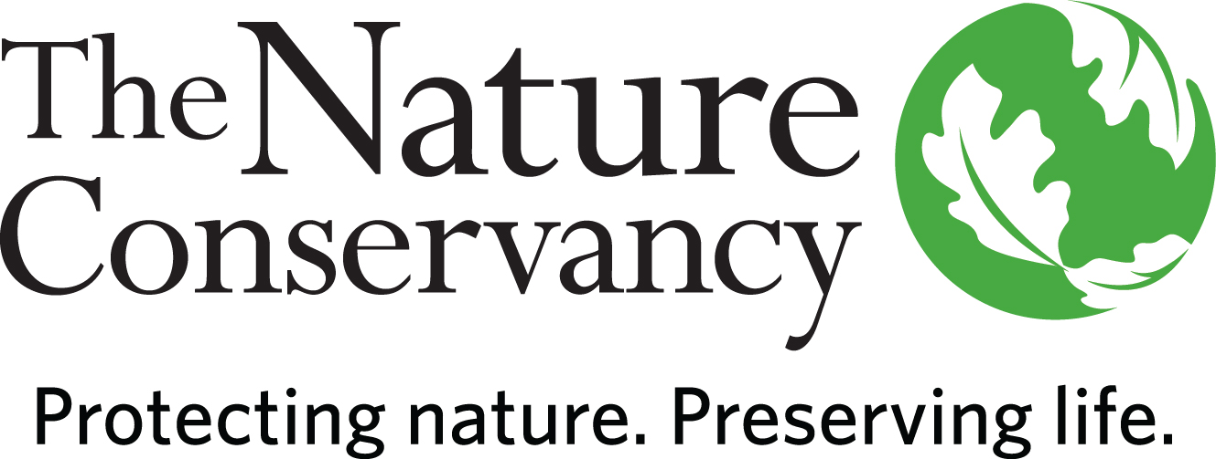
JOB TITLE | Burn Crew Member
JOB FAMILY | Conservation
JOB NUMBER | 450006
SALARY GRADE | 2
STATUS | Hourly
DATE | June 2018

A LITTLE ABOUT US
Since 1951, The Nature Conservancy has been doing work you can believe in protecting the lands and waters that all life depends on. As a science-based organization, we create innovative, on-the-ground solutions to our world’s toughest challenges so that we can create a world in which people and nature thrive.
We’re rooted in our Mission and guided by our Values, which includes a Commitment to Diversity and Respect for People, Communities, and Cultures. We know we’ll only achieve our Mission by hiring and engaging a diverse workforce that reflects the communities in which we work. Whether it’s career development, work/life balance, or a rewarding mission, there’s lots of reasons to love life #insideTNC. Our goal is to cultivate an inclusive work environment so that all of our colleagues around the globe feel a sense of belonging, and that their unique contributions to our mission are valued.
Although you’ll see requirements in our postings, we recognize that people come with talent and experiences outside of a job. Passion, innovation, and diversity are all key components to advancing our Mission and we encourage you to apply.
All TNC staff based in the U.S. or a U.S. Territory are required to be fully vaccinated against COVID-19. Proof of receiving one of the vaccines approved in the U.S. (Pfizer, Moderna, or Johnson & Johnson) shall be condition of employment and must be provided prior to starting work. TNC is an Equal Opportunity Employer, and reasonable accommodations for candidates who cannot be vaccinated due to a valid medical or religious reason will be considered.
YOUR POSITION WITH TNC

The Burn Crew Member (BCM) will work as part of the Southern Illinois Interagency Habitat and Fuels Crew (SIIHFC). The SIIHFC works collaboratively with the Shawnee National Forest, Illinois Department of Natural Resources, and others to implement stewardship activities on a landscape-level scale in the southernmost 11 counties of Illinois.

ESSENTIAL FUNCTIONS

The BCM participates in local wildland fire operations to support fuels management and ecological restoration through prescribed fire, and community and resource protection through the suppression of wildfires. Wildland fire duties related to the preparation, implementation and management of fire include creating fuel breaks, snagging, ignitions, holding, suppression, mop-up, cold-trailing and monitoring. The BCM will also have opportunities to participate in out-of-state wildfire suppression during the summer wildfire season as an administratively determined (AD) temporary hire through the Illinois Interagency Dispatch Center.

When not performing fire related duties, the SIIHFC supports partners in non-native invasive species (NNIS) management, timber management, monitoring, and other special projects. NNIS management is conducted throughout the year and achieved through foliar herbicide applications utilizing backpack sprayers and UTV-mounted pump sprayers, and mechanical methods such as cut-stump herbicide applications, hack-and-squirt, and hand pulling. Timber management includes timber/forest stand improvement (TSI/FSI) and site preparation, and generally requires using chainsaws to fell or girdle undesirable trees. Monitoring projects include post-burn fuels and fire effects monitoring and NNIS monitoring and inventories.

As part of the BCM’s ongoing professional development, they will be responsible for keeping abreast of new burn techniques and equipment to enhance skills and maintain/grow professional fire certification credentials. In addition, they shall work to build and maintain relationships in the professional fire community and in the local community where the Conservancy works.

RESPONSIBILITIES & SCOPE

- Work collaboratively with partners to achieve shared goals in fire management.
- Perform other assigned conservation duties (NNIS, timber, monitoring, etc.) in coordination with agency partners when not needed for preparing burn units or conditions are not conducive to fire.
- Safely perform tasks, maintain a high level of situational awareness, and identify potential operational hazards to ensure crew safety.
- Work in a high stress, goal-oriented, team environment.
- Maintain flexibility to quickly change tasks/roles and work within varying frameworks of supervision and command structure.
- Perform arduous work in variable weather conditions, at remote locations, on difficult and hazardous terrain, and under physically demanding circumstances.

MINIMUM QUALIFICATIONS

- High school diploma and 6 months of related experience.
- Must be qualified as a Fire Fighter Type 2 (FFT2), including Introduction to ICS (I-100), Human Factors on the Fire line (L-180), Introduction to Wild Land Fire Behavior (S-190), Firefighting Training (S-130), and one training burn serving under the supervision of a qualified FFT2. See http://www.tncfiremanual.org/firefighter.htm
- Must achieve physical fitness standard as determined by local Fire Program Manager and the TNC Fire Manual.
- Experience operating and maintaining various types of hand tools and power equipment (chainsaws, leaf blowers, brush cutters).
- Must have valid driver’s license and good driving record.
- Must obtain and maintain related licenses or certifications as required (First Aid/CPR, Pesticide Applicator, Driver’s License, etc.).

DESIRED QUALIFICATIONS

- Multi-lingual skills and multicultural or cross-cultural experience appreciated.
- 6 months -1 year of related experience.
- Completion of S-212 (Wildland Fire Chainsaws)
- Proficiency in identifying trees and non-native invasive species (NNIS) commonly found in the central hardwoods.
- Experience in off-road operation of trucks and UTVs, towing trailers and maneuvering them with limited space.
- Ability and willingness to follow instructions from colleagues.

ORGANIZATIONAL COMPETENCIES

Builds Relationships | Builds productive relationships by interacting with others in ways that enhance mutual trust and commitment.
Collaboration & Teamwork | Works collaboratively with stakeholders across levels, geographies, backgrounds, and cultures to improve decisions, strengthen commitment, and be more effective.
Communicates Authentically | Communicates proactively and in a timely manner to share information, persuade, and influence with the appropriate level of detail, tone, and opportunities for feedback.
Develops  Others | Takes ownership to help develop others’ skills, behaviors, and mindsets to help them maximize their workplace contributions.
Leverages Difference | Demonstrates commitment to harnessing the power of differences strategically; consistently sees, learns from, and takes strategic action related to difference; and demonstrates the self-awareness and behaviors to work across differences of identity and power respectfully and effectively with all stakeholder. Actively seeks to build and retain a diverse workforce and fosters an equitable inclusive workplace by drawing upon diverse perspectives.
Systems  Leadership | Thinks and acts from a broad perspective with a long-term view and an understanding of 1) the dynamic nature of large-scale challenges and 2) the need for integrating five key practices: skillfully engaging appropriate people; providing a clear process for change; taking a holistic view of situations; focusing on a small number of strategic actions, while learning from and adapting them over time; and being aware of how one’s own thinking or patterns of behavior may be limiting change.

This description is not designed to be a complete list of all duties and responsibilities required for this job.

