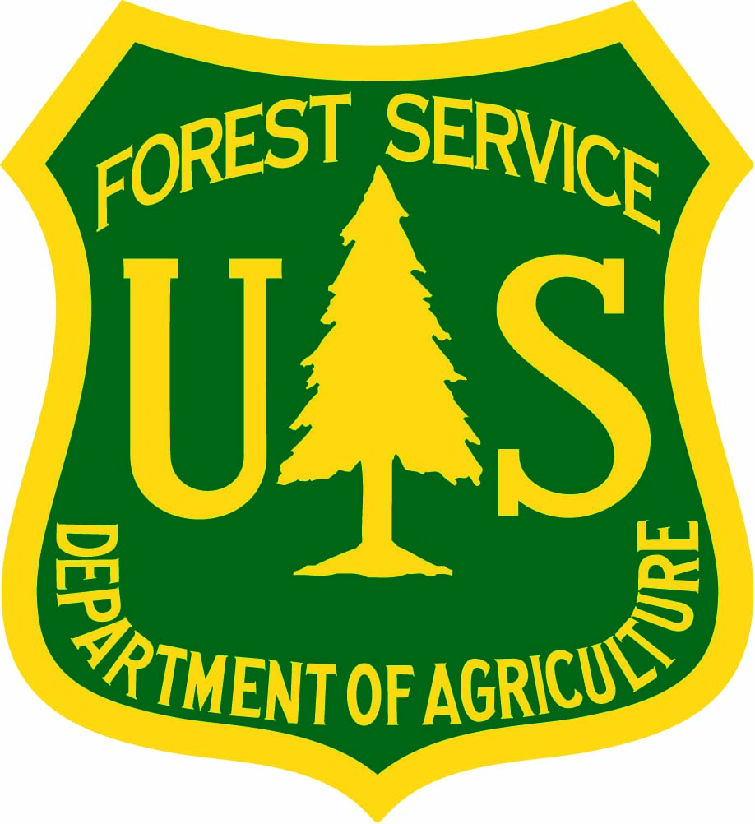
Hoosier National Forest
OUTREACH NOTICE/ VACANCY ANNOUNCEMENT
Forestry Technician (Recreation), GS-0462-6/7
Bedford, IN

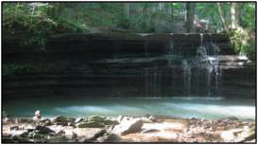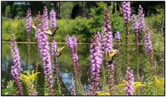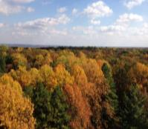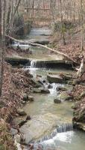
The Hoosier National Forest is filling one vacancy for a full-time permanent Forestry Technician (Recreation), GS-0462-6/7. The duty station is in Bedford, Indiana. For additional details on the position, please email Stacy Duke, Forest Recreation Program Manager at stacy.duke@usda.gov or call (812) 276-4726.
This Outreach Notice is running concurrently with the application timeline. The application deadline will end on Friday October 15th, 2021. Applicants need to apply through the USA JOBS process.
Vacancy Announcement Number: 21-R9OCR-462-REC-6-7G
Link to Vacancy Announcement: USAJOBS - Job Announcement
*** Select Bedford, Indiana as the desired duty location at the time of completing the application.***

Position Description and Responsibilities:
This position supports the recreation program primarily on the Brownstown Ranger District of the Hoosier National Forest. Occasional work on the Tell City Ranger District will occur. The main duties include developed recreation work (campgrounds, dispersed camping, and recreation sites) but will also support the trails and wilderness programs as needed. Campground maintenance and operations including fee collections, facility maintenance, hazard trees assessments and removal, operating equipment such as mowers, tractors, chainsaws and power tools, and some oversight of a wastewater treatment plant are primary functions of this position. Interaction with the public serving as a Forest Protection Officer and communications with campground hosts and volunteers will occur on a regular basis. This position will serve as a Collection Officer and Contracting Officer Representative. Data collection and entry for developed recreation reporting requirements will be expected of this position. Work is field going and requires working in various outdoor terrain and weather conditions. The work schedule is Tues-Saturday (occasional Sunday) during peak recreation seasons and Mon-Fri during the off-season if desired. Applicants must possess a valid driver’s license.

Description of the Forest:
The Hoosier National Forest encompasses nearly 204,000 acres in South Central Indiana stretching south from Bloomington to the Ohio River and is located within a drive of two hours or less from Cincinnati, Ohio; Evansville and Indianapolis, Indiana; and Louisville, Kentucky. Two ranger districts include the Brownstown District in Bedford, Indiana and the Tell City District in Tell City, Indiana.
The Hoosier National Forest sits in the unglaciated hills of Southern Indiana. The Forest provides a range of opportunities and resources for people to enjoy. The many recreation opportunities including camping, fishing, hiking, horseback riding, hunting, mountain bike riding, and viewing scenery. The only congressionally designated wilderness in Indiana, the 13,000 acre Charles C. Deam Wilderness provides opportunities for users desiring higher levels of solitude. In addition the Forest has over 265 miles of trails for hiking, biking, or horseback riding.
The Hoosier works to provide integrated resource management on the complex mosaic that make up National Forest System Lands in Indiana. Only 31% of the land within the Forest Boundary is National Forest System land, this scattered ownership pattern adds a complexity to the management of this valued natural resource. Forest managers are responsible for protection of some very unique resources. The Hoosier is located in an area rich in caves and karst features. These underground features are largely unknown to most Forest visitors but are home to many species that are specific to these habitats. The Hoosier has five endangered or threatened species: the fanshell and rough pigtoe mussels reside in rivers to the south; the gray, Indiana and northern long-eared bats and their habitat occur throughout the Forest. The wildlife program on the Forest focuses on management to provide habitat for these species as well as many others that occur throughout the area.
The Forest works to maintain and restore sustainable ecosystems. The vegetation management on the forest focuses on promoting native oak and hickory regeneration, reducing nonnative pine planted to restore over farmed lands, and reducing nonnative invasive plant and animal species.
The Hoosier National Forest organization is non-traditional with an emphasis on placing resource specialists closer to the ground. Certain Forest-level staff functions that traditionally reside in a Supervisor’s Office work in a team environment and serve as District-level program managers. This serves to broaden District interdisciplinary teams and improve technology transfer, customer service, and quality of stewardship. We view the Districts as the backbone of the Forest Service organization and emphasize customer service at that level. Additional information and an orientation video of the Forest may be found at http://www.fs.fed.us/r9/hoosier.
Bedford, IN.
The Hoosier National Forest Supervisor’s Office is co-located within the Brownstown Ranger District in Bedford, Indiana. Bedford is a full-service community of approximately 14,000 residents. Bedford has excellent schools, outstanding shopping, cultural amenities, and small town atmosphere. Bedford is in the Eastern Time zone and features a broad-based economy. Major area employers include GM Powertrain, Indiana Limestone, Manchester Tank, and Stone City Products. Bedford is known as the “Limestone Capital of the World” because of the abundance and quality of the limestone which has been used on many landmark buildings in the U.S., including the Empire State Building and the Pentagon.
Bedford has five elementary schools, one junior high school, one high school (includes area vocational school) and Bedford City College, which offers adult education and college credit courses. Eighteen miles north of Bedford is Bloomington, home of Indiana University. In addition, Bedford is within commuting distance of six degree granting institutions. Indianapolis is approximately 70 miles north and is the state capitol.
Housing prices, for purchase or rent, are reasonable and affordable. Local services include a wide variety of places of worship, a library, two hospitals providing comprehensive medical services, and a variety of banking, shopping facilities, and restaurants.
There are several communities within commuting distance of Bedford. Links are provided below:
Bedford, Indiana; Bloomington, Indiana; Mitchell, Indiana; Seymour, Indiana
Climate:
The temperature in southern Indiana varies north to south. Although Indiana sometimes has temperatures below zero during the winter, the average temperatures in January range between 17°F and 35°F. Rainfall is distributed evenly throughout the year. The average annual precipitation statewide is 40 in, ranging from about 35 in (89 cm) near Lake Michigan to 45 inches along the Ohio River; from, 1981 - 2010, Indianapolis had an average of 42 inches annually. The annual snowfall averages about 26 inches.
Places of Worship:
Churches representing all major denominations; as well as Jewish, Islamic, Buddhist and other places of worship; can be found in communities across the area.
Economy:
Real estate in the area is moderately priced, as are utilities. Tourism is a developing economic force in the area. In recent years, several wineries and craft breweries have opened, adding to the tourism opportunities in the region.
Healthcare:
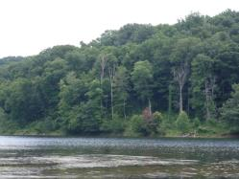
Healthcare facilities serving the area include full facility IU Health Bedford Hospital and St. Vincent Dunn Hospital, in Bedford, along with full service hospitals and medical practices in Bloomington. Services at these hospitals include cardiac units, oncology and neonatal units. Other hospitals providing care in the general area of the Hoosier include Perry County Memorial in Tell City, Indiana; Deaconess in Evansville, Indiana; and University of Louisville Hospital in Louisville, Kentucky. All the hospitals provide 24-hour emergency room physician coverage and specialists.
Recreational and Cultural Activities:
The region has many opportunities for outdoor activities as well as small town festivals and fairs. In addition there is easy access to larger cities including Cincinnati, Ohio; Chicago, Illinois; Indianapolis, Indiana; Louisville, Kentucky; Nashville, Tennessee; and St. Louis, Missouri.

Non-Discrimination Statement
In accordance with Federal civil rights law and U.S. Department of Agriculture (USDA) civil rights regulations and policies, the USDA, its Agencies, offices, and employees, and institutions participating in or administering USDA programs are prohibited from discriminating based on race, color, national origin, religion, sex, gender identity (including gender expression), sexual orientation, disability, age, marital status, family/parental status, income derived from a public assistance program, political beliefs, or reprisal or retaliation for prior civil rights activity, in any program or activity conducted or funded by USDA (not all bases apply to all programs). Remedies and complaint filing deadlines vary by program or incident.
Persons with disabilities who require alternative means of communication for program information (e.g., Braille, large print, audiotape, American Sign Language, etc.) should contact the responsible Agency or USDA’s TARGET Center at (202) 720-2600 (voice and TTY) or contact USDA through the Federal Relay Service at (800) 877-8339. Additionally, program information may be made available in languages other than English.
To file a program discrimination complaint, complete the USDA Program Discrimination Complaint Form, AD-3027, found online at http://www.ascr.usda.gov/complaint_filing_cust.html and at any USDA office or write a letter addressed to USDA and provide in the letter all of the information requested in the form. To request a copy of the complaint form, call (866) 632-9992. Submit your completed form or letter to USDA by: (1) mail: U.S. Department of Agriculture, Office of the Assistant Secretary for Civil Rights, 1400 Independence Avenue, SW, Washington, D.C. 20250-9410; (2) fax: (202) 690-7442; or (3) email: program.intake@usda.gov.

