Clemson University’s Youth Learning Institute
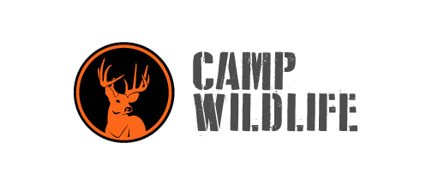
Camp Wildlife Job Description

Title: Shooting Sports and Wildlife Instructor/Counselor
Work Dates: May 23 – August 6, 2021
Location: Camp Bob Cooper, Summerton, South Carolina

Description:
The camp is located on YLI’s Camp Bob Cooper directly on Lake Marion (South Carolina’s largest lake). A majority of the camp week will focus on hunting and fishing techniques, wildlife ecology, ATVs, outdoor survival skills and shooting sports activities (shotgun, rifle and archery). Instructors will be trained and certified through USA Archery, South Carolina 4H Shooting Sports, ATV Safety Institute and South Carolina Department of Natural Resources. In addition to these activities, we will also utilize other components such as swimming, team building, and various recreation activities. To see more about the camp, visit https://wildlifesummer.camp/.

Principal Duties:
- Teach components of the Wildlife Ecology and Shooting Sports curriculum (training provided).
- Lead students in daily program classes and activities (wake-up, meals, campfire, and wrap-up).
- Be actively involved in all program activities, leading and participating in evening recreational and instructional times as scheduled.
- Perform direct supervision of children while involved in classes and activities.
- Perform camp counselor duties including staying and attending to campers over night while they are at camp.
- Assist in routine clean up.
- Perform tasks assigned by leadership staff.

Qualifications:
- Pursuing BA or BS in Biology, Wildlife and Fisheries, Natural Resources, or related field is preferred –Juniors, Seniors, and graduates preferred.
- Experience with hunting and shooting sports preferred but not necessary (we will train those without experience).
- Residential camp experience preferred.
- Must have the patience, understanding, flexibility, and energy to work and live with campers and staff.
- Must be willing to sacrifice, adapt, and work hard as part of a team.

Salary: $440 - $580 twice a month plus lodging, meals during camp and a sickness/accidental insurance plan.

Contact: If you are interested in the position please send your resume and three professional references to Candice Heatherly at ceharpe@clemson.edu by March 1, 2021.

Clemson University is an Affirmative Action/Equal Opportunity employer and does not discriminate against any individual or group of individuals on the basis of age, color, disability, gender, national origin, race, religion, sexual orientation, veteran status or genetic information.

