FOR 220 – Intro to Forest Recreation

Course Syllabus

Professor: Dr. Logan Park
Office: Ag Building, South Wing, 194D
Office hours: by appointment; I’m generally available afternoons.
618-453-7476 (office)
540-315-7205 (txt)
Logan.Park@siu.edu
Any students with individualized learning or mobility needs should arrange to meet with me as soon as possible. Modifications to the course structure for you have to go through DSS: http://disabilityservices.siu.edu/guidelines-and-forms/achieve-dss-comparison.html Once that’s done, I’m enabled to help you be rockin’ awesome… and effective, scholarly, intellectually curious, etc.

Purpose of the Course:
Outdoor recreation is an enormously popular pastime, with millions of Americans involved to various degrees in a wide array of activities. This course is designed to familiarize you with trends and major concepts in outdoor recreational use of wildlands and natural areas. Emphasis is placed on state- and federal-level parks, forests, preserves, and other protected areas. You will be introduced to modern principles of recreation management, visitor impact assessment techniques, and environmental interpretation. We will examine these topic areas through a combination of readings, chat/videoconferencing, outdoor exercises on your own, and hands-on laboratory assignments. If you’ve ever considered working as a technician, specialist, ranger, guide, outfitter, etc., this course is for you.

Course Objectives:
- Development of appreciation for outdoor recreation and related thinkers and philosophies
- Definition of key concepts, personalities, and important places
- Examination of various forms of outdoor recreation and their individual and societal benefits
- Survey of career options in recreation management, from recreation technician to agency directorship
- Historical events, developments, and context important to modern recreation management
- Profile international, federal, state, and local; public and private institutions concerned with outdoor recreation
- Familiarity with local outdoor recreation opportunities
Course objectives’ accomplishment will be evaluated through quizzes, exams, and class exercises.

This is one of many kinds of outdoor recreation, and numerous notable things are happening in this image. We’ll learn all about them.

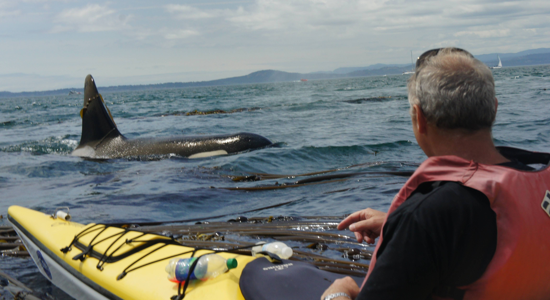

This (below), however, may not be outdoor recreation. We’ll learn all about why not.

Required Course Materials:
To participate well in class, you will be expected to have read all assigned texts by the beginning of the class period for which they are assigned.

Primary Text:
Jensen, C. and Guthrie, S. (2006). Outdoor Recreation in America, 6th ed. Champaign, IL: Human Kinetics. 371 pp.
Is it required? Yes, it is.
May you get it free through many of our fine state’s libraries? Yes, you can.
Additional course materials will be posted as needed at:
Hey, listen! This is also called D2L, or Desire 2 Learn
- http://online.siu.edu (likely)
- http://logan-park.org (likely)

Grading System:
Your grade is a weighted average of participation, quizzes, exams, and class activities/exercises. Each of these four components of the course is worth 25% of your grade. Grades will not be curved. Due to the need to finalize grades at the close of the semester, late assignments will not be accepted at all after the due date of the final exam.
A | 90.0 – 100.0% | Demonstrated mastery of material and applications, critical thinking, preparedness
B | 80.0 – 89.0% | Demonstrated above average proficiency, few errors in content
C | 70.0 – 79.0% | Demonstrated average/below average proficiency, errors in content are common
D | 60.0 – 69.0% | Demonstrated poor proficiency, errors in content are numerous
F | 59.0 and lower | Unacceptable grasp of course material and applications

Participation:
You are expected to participate everywhere possible in lecture and lab session discussions. Online “attendance” via the course website (Desire2Learn) applies toward the participation portion of your grade evaluation.
Why? This course on your transcript with a grade certifies that you’ve demonstrated mastery over our course topics. “No show means no go” in terms of me being able to promise your future employer that you are--in fact--living, intelligent, and trained in our particular course’s content.
In addition, you are responsible for making prior arrangements with me in the event that you must miss a class or laboratory session.
Meaningful learning about forest recreation through your computer or phone’s screen is like “dancing about architecture.” Great idea on paper (screen?) but you’ll be asked to actually go outdoors, do fun things, and document them thoroughly.

Quizzes:
A series of quizzes will be given during the course of the semester. They are opportunities for you to demonstrate your close familiarity with the assigned readings, class exercises, and lecture material. Quizzes may be unannounced and will be given during the class period or online. Questions will mostly be in true/false, multiple choice, short answer, matching, or fill-in-the-blank format.

Final Exam:
The final exam is considered cumulative across all course materials, and will be in written format. You will be expected to demonstrate your mastery of knowledge over readings, lectures, discussions, and laboratory assignments; also, your ability to apply and think critically over what you have learned will be examined. If you are for any reason unable to take the final exam, you must make prior arrangements with me no later than two weeks before the final exam date.

Assignments:
All reports must be typewritten in 12-point font and double-spaced. Any associated documents should be clearly legible and securely attached to the lab report. Lab reports are equivalent to assigned papers and must be treated with clear professionalism. Handwritten submissions will result in your being ejected into low earth orbit.
Proofread your work. Enlist a friend’s help in reading over your written assignments for grammar and logical flow. Reading your work aloud to yourself can be almost as effective when no one else is available to help.
Late assignments will be penalized. Assignments are due at the beginning of the lecture or laboratory period for which they are assigned. For each day that an assignment is late, 10% will be removed from its maximal grade. For assignments that cannot be turned in by the deadline due to extenuating circumstances, you must make prior arrangements with me.
Spelling and grammar errors will count against your grade. All assignments must have a heading that includes your name, the date, and the title of the assignment. Always keep a personal copy of your assignment in case the turned in copy is lost or damaged in transit.
All assignments must be turned in to me as electronic files, unless otherwise indicated. You may turn in assignments to my email address. Do not slide assignments under my office door, as they may get mangled or “relocated” by custodial staff.

Ethics:
You are expected to understand and follow university codes of ethics. Your work must be your own; anywhere you utilize the ideas of others, proper and clear credit must be given. Plagiarism is a serious offense and usually involves receiving a grade of “F” for the course, in addition to other punishments. Group work must be evenly distributed among group members. If you are unclear at any time on what to do or not to do for this course with regard to ethical practices, please discuss it with me as soon as possible.

Large scale emergencies:
Southern Illinois University Carbondale is committed to providing a safe and healthy environment for study and work. Because some health and safety circumstances are beyond our control, we ask that you become familiar with the SIUC Emergent Response Plan and Building Emergency Response Team (BERT) program. Emergency response information is available on posters in buildings on campus, available on the BERT’s website at www.bert.siu.edu, Department of Public Safety’s website at www.dsp.siu.edu (disaster drop down) and in the Emergency Response Guidelines pamphlet. Know how to respond to each type of emergency. Responding to emergencies in an online course is a different situation than usual; if you’re on-campus, shelter in place or get to a safe location as soon as possible.

Course Content Areas:
Following is a general, unordered outline of the topics that this course will cover. Required readings will be assigned throughout the course of the semester. Readings are subject to change at my discretion according to the needs of the class.

- Fundamental Concepts
  - Definitions in leisure - J & G Chapter 1
- Local outdoor recreation opportunities
- Career Opportunities in Outdoor Recreation – J & G Chapter 19
- Benefits of Leisure and Outdoor Recreation
  - Beneficial Outcomes Approach to Leisure (BOAL) – J & G Chapter 3
- Historical Context and Development of Outdoor Recreation in America
  - Philosophical and social evolution in outdoor recreation – J & G Chapter 2
- Legal frameworks in American land management and associated personalities
  - Technological innovation in outdoor recreation
  - Trends and forecasts – J & G Chapter 4, 5, 21
- Modern Recreation Providers
  - Recreation providers mosaic
  - International
  - Federal – J & G Chapter 9, 10, 11, 12
  - State – J & G Chapter 13
  - Regional
  - Local – J & G Chapter 14
  - Private nonprofit – J & G Chapter 16
  - For-profit
  - Partnerships
- Science-Based Recreation Management
  - Resources of recreation – J & G Chapter 6, Chapter 7
  - Impacts of recreation - J & G Chapter 20
  - Policy, management, planning, and administration - J & G Chapter 8, 17, 18
  - Managing visitor behaviors

Extra Credit Opportunities

How It Works
Enjoy any of the following opportunities throughout the semester, or create your own similar trip. Return and provide to me a brief trip report identifying things we talk about in class as you experienced them. Receive extra credit.

Example Extra Credit Opportunities of Last Year: 2013
Event | Cost | When | Where | Transp. Included | Who
Tecumseh Trail Overnight | 60 | March 2-3 | Eastern/Southern Illinois (Eagle Mountain and Stoneface) | Yes | SIU Basecamp
Spring Break Trip | 450 | March 9-15 | Everglades/Cumberland Island National Seashore | Yes | SIU Basecamp
Sunset Photography/ Paddle/ Stargazing/ Bonfire | 25 | March 21 | TBD | Yes | SIU Basecamp
Morel/ Wildflower Hike | 10 | April 13 | Giant City State Park and surrounding areas | ? | SIU Basecamp
“Herping… It’s not what you think it is” (Herpetology at Snake Road) | 20 | April 20 | Snake Road | Yes | SIU Basecamp
Pet Hike (Teaming Up With Local Shelter) | Free | May 2 | Green Earth Chautauqua Bottoms Trail | ? | SIU Basecamp, Green Earth
Green Earth Trail Maintenance Workdays | Free | ? | Multiple locations around Carbondale | No | Green Earth, Dr. Park
Sweets For Your Sweetie | 10 | February 13 | ? | ? | SIU Basecamp
10 Places In Southern Illinois You Never Knew Existed | 10 | February 21 | Student Rec Center Conference Room | N/A | SIU Basecamp
Slacklining/ Tricklining… “No, It’s Not a Tightrope | 10 | March 27 | Campus Lake | N/A | SIU Basecamp
Off The Beaten Path, 4 x 2 hour hikes | 30 for all or 10 each | March 6, 20, April 3, 10 | Giant City Trail, Panther Den Wilderness Area, Turkey Bluff Trail, Trillium Trail | Yes | SIU Basecamp
Nature Photography Contest | Free | April | All over Southern Illinois | N/A | Friends of the Shawnee National Forest

Earth Day Lake Clean Up | Free | April 22 | Cedar Lake | No | SIU Basecamp
Holy Boulders Climbing Area Adopt-A-Crag | 10 | May 4 | Holy Boulders | ? | SIU Basecamp
7 Wilderness Areas | Free | All semester | Southern Illinois | ? | You
Shawnee National Forest | Free | All semester | Southern Illinois | ? | You
Crab Orchard National Wildlife Refuge | Free | All semester | Southern Illinois | ? | You
Giant City State Park | Free | All semester | Southern Illinois | ? | You
Garden of the Gods | Free | All semester | Southern Illinois | ? | You

Congratulations! You’ve found the embedded assignment!

Go here:
http://links.logan-park.org/index.php/?i=14
OR here:
https://docs.google.com/a/siu.edu/spreadsheet/viewform?formkey=dEwxdDlJb3YtZXFfbjF5Tm9FeFFuWEE6MQ
(The links point to the same place) and follow the instructions to complete this short assignment.

