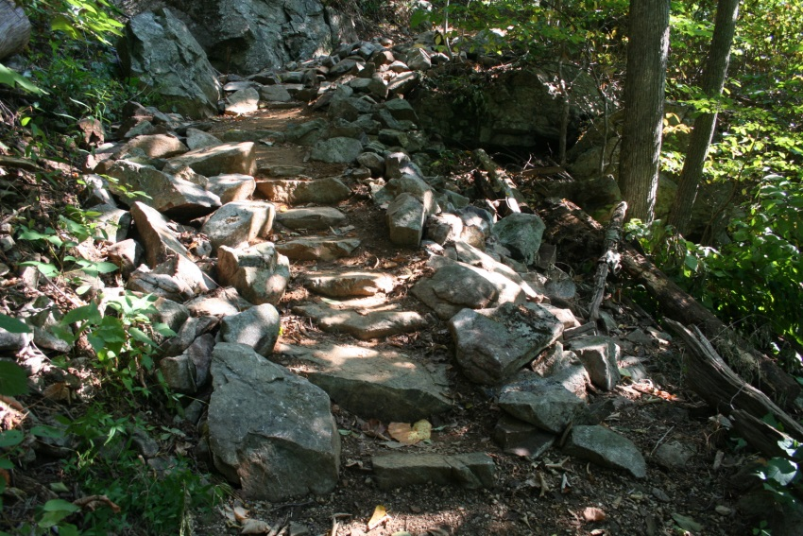
Trails Training For Giant City Volunteers and Staff!

Wednesday, February 4th and 11th
Giant City Visitors Center
Are you a Giant City volunteer that likes to get out and do trail work? If so, head on over to the Visitor’s Center to learn all about building and maintaining trails! Kelly Pearson with the U.S. Forest Service will be conducting training from 9-1 on both dates. This training will consist of both classroom and actual trail building time. Please give the Visitors Center a call if you would like to attend, 618-457-4836. (You can also email Jen at Jennifer.randolph@illinois.gov)

