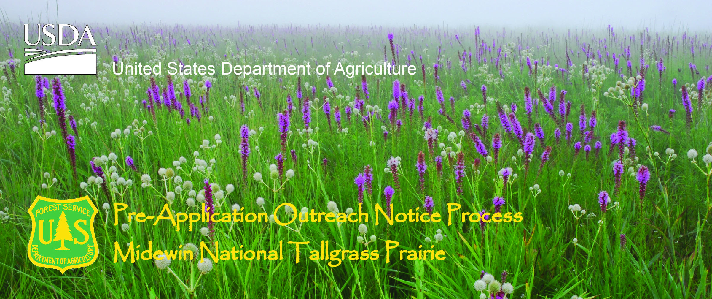

Forestry Technician Position
Forest Service Region 9
Midewin National Tallgrass Prairie
Wilmington, Illinois 60481
http://www.fs.usda.gov/midewin

The Midewin National Tallgrass Prairie will soon be advertising to fill five positions working in trails, trailheads, dispersed recreation and protection of natural resources. The official duty station is Wilmington, Illinois located about 45 miles southwest of Chicago. Midewin was established in 1996 as the first national tallgrass prairie in the country and in the National Forest System. It is also the largest open space in the six-county Chicago metropolitan area.

About the Midewin National Tallgrass Prairie
The Midewin National Tallgrass Prairie was established in 1996 as part of the peace time conversion of the former Joliet Army Ammunition Plant and is administered by the USDA Forest Service. Midewin is implementing its first Land and Resource Management Plan to accomplish the four purposes outlined in its establishing legislation --to manage the land and water resources to conserve and enhance native populations and habitats of fish, wildlife, and plants; to provide opportunities for scientific, environmental, and land use education and research; to allow continued agricultural use under certain conditions; and to provide a variety of recreation opportunities.

Midewin operates in an unusually integrated manner with a wide variety of partners. It is the largest contiguous open space, at approximately 19,000 acres in northeastern Illinois. Check out our website at www.fs.fed.us/mntp/ to gain an overview of what's current and planned at Midewin.

Major Duties
The incumbent for this position performs a variety of tasks to support public access, maintaining recreation infrastructure, and developing infrastructure, including trails, trailheads, and interpretive facilities. The following is only a summary of what the position duties:
- Oversees and participates in the construction and maintenance of trails and trailheads.
- Performs safety hazard analyses of trails and related facilities and takes or recommends corrective action. Inspects areas of concentrated public use, trails, and special use permits for compliance with the permit and management plans, public health, and safety
- Provides detailed information about non-motorized opportunities to visitors and explains Forest Service rules and regulations. Provides information on resource management practices, regulations, and current conditions. Collects, compiles, and summarizes information for trail data management systems.
- Uses various types of equipment including mowers, skid steers, UTV’s and tractors.
- Work schedule includes weekends, with varying start and end times during high use seasons.
- Working environment is outside in all type of weather and seasons. Work terrain may be steep and uneven with thick vegetation. Assists in the maintenance of trail facilities, such as toilets, road closure gates, barriers and other miscellaneous structures.
- Coordinates and serves as field work leader for crews and volunteers.

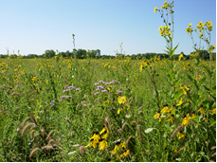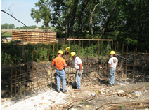

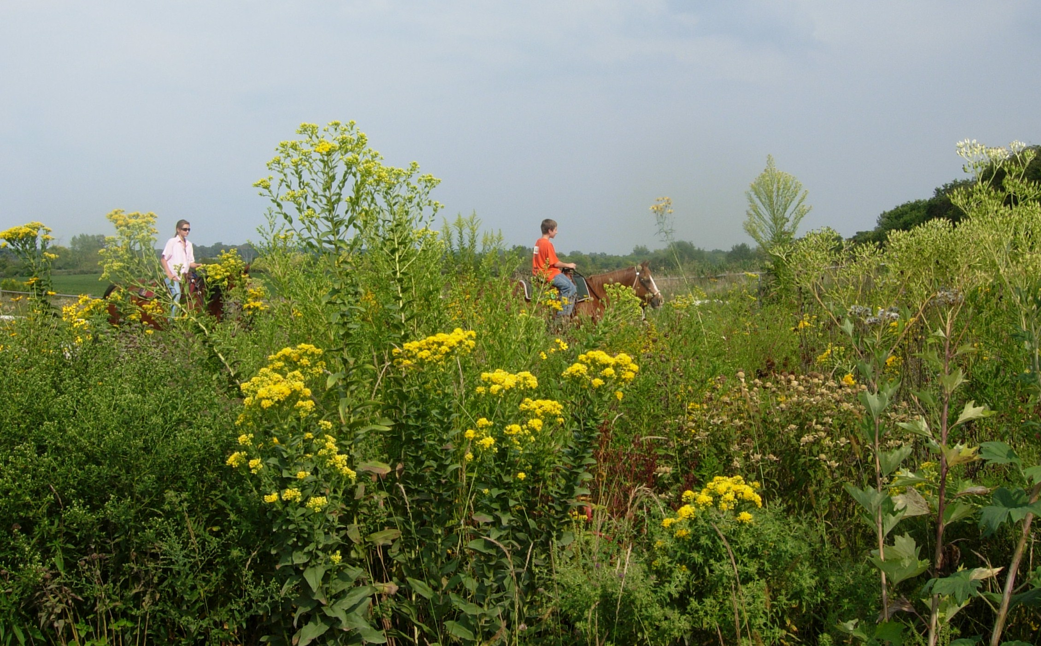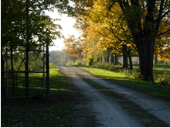

Pay Band

$13.35 - $16.77/ Hour

The Midewin National Tallgrass Prairie Area

Although Midewin is located 45 miles southwest of Chicago, the third largest metropolitan area in the country, a rural atmosphere predominates throughout the small to mid-sized farming communities that surround Midewin. There are numerous schools, hospitals, doctors, churches, and communities to choose from and cultural opportunities are nearly limitless.

Wilmington, Illinois is a full service community with a population of 5,000 and is located adjacent to the Kankakee River. Fishing is quite popular along the Kankakee and throughout various other rivers and small lakes that surround the area. The climate in this area is defined by four distinct seasons. Summer temperatures can reach over the 90’s, accompanied with, high humidity and heat index in the 100s or more. Spring and fall have average temperatures in the 60’s and 70’s. Winter temperatures will frequently dip below freezing and it is not unusual to see several inches of snow covering the ground November through March.

The Midewin headquarters is located along State Highway 53, two miles north of the town of Wilmington, Illinois. Midewin team members live in many area communities, ranging from the more urban Joliet, population 83,000, to smaller communities tucked around the surrounding farm fields, like Essex, 500, or nearby Elwood, 1,000 For more information on Wilmington, there is a community website available at http://www.wilmington-il.com/ Many options for residing in larger communities are available within an easy half hour commute. There is no public transit available to the Midewin office. The closest Metra station providing access to Chicago is in Joliet.

Medical facilities are plentiful, including easy access to nationally-recognized institutions in Chicago. Cultural events range from performances at the historic Rialto Square Theater in Joliet, to playhouses at local universities, to a variety of festivals celebrating local heritage, to the wide theater, restaurant, and museum options of Chicago.

If you are interested in this position please respond by February 13, 2015.

For additional information about this position, please contact: Rick Short, Acting Public Services Team Leader by email at rshort@fs.fed.us or by phone at (815) 423-6370.

