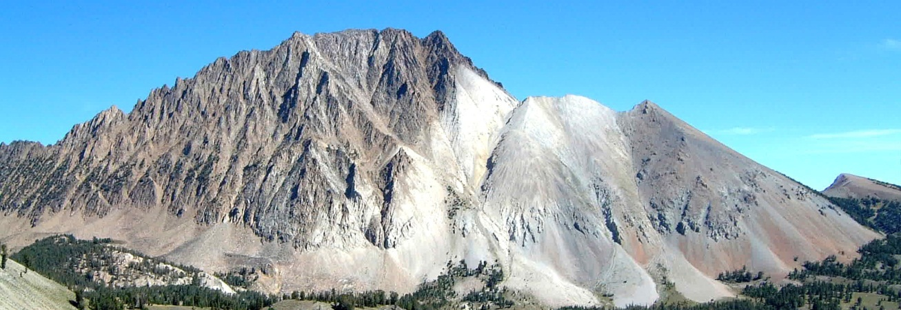
Recreation/River Ranger/Trails/Wilderness
Sawtooth National Recreation Area • Sawtooth National Forest

The Sawtooth National Recreation Area will be seeking diverse and high quality candidates to fill temporary seasonal employment in Recreation, Wilderness, Trails and River management programs. The positions are located in and around Stanley, Idaho. Bunkhouse facilities may be available but are not guaranteed. Individuals working on the Sawtooth National Recreation Area can expect to perform their duties in a variety of weather conditions ranging from intense heat and sun to extreme cold with rain and snow. Applicants must be physically fit and at least 18 years of age.
These positions will start around the end of May and last to the end of September. The ability to work for the duration of these dates can be a selective factor.
These positions are open for applications starting January 14 and close as early as January 20. When applying for these positions you MUST choose the correct duty location before submitting your application. If you do not choose this location as a location choice your name will not appear on the list of applicants that we receive.
Forestry Aid / Technician (Recreation)
Positions: GS-0462- 03/04/05
The Aid position works primarily in campgrounds and dispersed recreation sites. The individual will clean facilities and maintain improvements such as picnic tables, restrooms, fire rings, fences, etc. The individual on occasion will interact with the public answering routine questions and checking compliance with rules and regulations. The individual works independently or on a small crew, and will be required to use hand tools and cleaning supplies.

The selected individual(s) for the Technician Position will assist in the daily management of dispersed and developed recreation areas. The incumbent will be expected to maintain and clean facilities such as campsites, dispersed recreation sites and outhouses and make visitor contacts to educate and enforce area regulations. They will be responsible for operating and maintaining all vehicles and tool associated with duties of the position. The selected individual will serve as a Forest Protection Officer (FPO) for the positions listed for Stanley. (The preferred candidate will have current FPO credentials and certification in first aid and CPR.)
Additional duties of this position include:
- Patrolling and monitoring recreation areas by vehicle, ATV, motorcycle or mountain bike, addressing issues as they arise.
- Monitoring the condition of facilities and resources, fixing, maintaining, and replacing items as needed.
- Participating in educational activities, answering questions, giving directions and working with visitors and other employees.
- Working with guides and outfitters to ensure compliance and provide information.
- Incumbent may be asked to respond to highway and land-based emergencies as well.

Individuals working on the Sawtooth National Forest can expect to perform their duties in a variety of weather conditions ranging from intense heat and sun to extreme cold with rain and snow. Applicants must be physically fit and at least 18 years of age. The incumbent will be working outdoors and may occasionally be required to spend the night in the field (sleep in tents and prepare meals in an outdoor environment). Bunkhouse facilities may be available but are not guaranteed. Work will be full time, 4-5 days/week, including weekends.

Grade/Series | Position Title | Duty Location | Vacancy Announcement Number | Contact
GS-0462-04 GS-0462-05 | Forestry Technician, (Recreation) | Stanley, ID | 15-TEMP-R40462-4-REC-DT-PM  Vacancy Opens 1/16/2015  Vacancy Closes 1/22/2015  15-TEMP-R40462-5-REC-DT-PM  Vacancy Opens 1/16/2015  Vacancy Closes 1/22/2015 | Jerry Cowan  (208) 774-3021  jeromecowan@fs.fed.us

Forestry Technician (FPO/River Ranger)
Positions: GS-0462-04/05
The selected individual(s) will serve as a Forest Protection Officer (FPO) and assist in the daily management of the Upper Main Salmon River. This section of river is extremely sensitive due to the presence of four aquatic endangered species; Sockeye and Chinook salmon, Steelhead and Bull trout. The incumbent will be expected to maintain and clean facilities such as campsites, dispersed recreation sites and outhouses and make visitor contacts to educate and enforce area regulations. They will be responsible for operating and maintaining all vehicles and tool associated with duties of the position.

Additional duties of this position include:
- Patrolling and monitoring river resources via raft/kayak, addressing issues as they arise.
- Patrolling and monitoring land-based recreation areas by vehicle, motorcycle or ATV addressing issues as they arise.
- Monitoring the condition of facilities and resources, fixing, maintaining, and replacing items as needed.
- Participating in educational activities, answering questions, giving directions and working with visitors and other employees.
- Assisting with aquatic invasive species inspections and monitoring Chinook salmon spawning redds.
- Working with guides and outfitters to ensure compliance and provide information.
- Respond to river-based emergencies. Incumbent may be asked to respond to highway and land-based emergencies as well.

Individuals working on the Sawtooth National Forest can expect to perform their duties in a variety of weather conditions ranging from intense heat and sun to extreme cold with rain and snow. Applicants must be physically fit and at least 18 years of age. The incumbent will be working outdoors and may occasionally be required to spend the night in the field (sleep in tents and prepare meals in an outdoor environment). Bunkhouse facilities may be available but are not guaranteed. Work will be full time, 4-5 days/week, including weekends.

The preferred candidate will be highly proficient operating rafts and/or kayaks on rivers with Class III and IV rapids. Additional preferred training: current FPO, first aid, CPR, and swift water rescue certifications.

Grade/Series | Position Title | Duty Location | Vacancy Announcement Number | Contact
GS-0462-04 GS-0462-05 | Forestry Technician, (FPO/River Ranger) | Stanley, ID | 15-TEMP-R40462-4-REC-DT-PM  Vacancy Opens 1/16/2015  Vacancy Closes 1/22/2015 | Jerry Cowan  (208) 774-3021  jeromecowan@fs.fed.us

Forestry Aid (Trail Crew) / Forestry Technician (Trails)
Position: GS-0462-03/04/05
The incumbent will independently perform a full range of standardized support duties specific to the trails program. The incumbent will use various tools and equipment to maintain and construct trails, install water-bars, and/or build rock walls. The incumbent will move or transport personnel and equipment to the project areas. The incumbent may perform independently or as a leader of one or more lower grade employees in maintenance or reconstruction of trail improvement projects. The incumbent will be working outdoors for extended periods of time. This will include living and working in an outdoor setting (sleep in tents and preparing meals in an outdoor environment), carrying heavy backpacks, tools and hiking long distances.
For the Forestry Technician Trail positions please highlight specialized trail experience including stock use, advanced trail building skills, leadership experience.
The incumbent may be required occasionally to explain and enforce forest rules and regulations. The incumbent may assist the unit by identifying and reporting additional resource needs or deficiencies.

Individuals working on the Sawtooth National Forest can expect to perform their duties in a variety of weather conditions ranging from intense heat and sun to extreme cold with rain and snow. Applicants must be physically fit and at least 18 years of age. Bunkhouse facilities may be available but are not guaranteed. Work will be full time, 4-5 days/week, including weekends.

Grade/Series | Position Title | Duty Location | Vacancy Announcement Number | Contact
GS-0462-03  GS-0462-04  GS-0462-05 | Forestry Aid (Trails)  Forestry Technician (Trails) | Stanley, ID  or  Obsidian, ID | 15-TEMP-R40462-3-AIDR-DT-PM  15-TEMP-R40462-4-TR-DT-PM  15-TEMP-R40462-5-TR-DT-PM  Vacancy Opens 1/14/2015  Vacancy Closes 1/20/2015 | Jay Dorr  208-727-5000  jdorr@fs.fed.us

COMMUNITY INFORMATION

Stanley, Idaho
Stanley is a remote rural community with a base population of 100, located at the foothills of the awesome Sawtooth Mountains. It is known for its excellent recreation opportunities; hiking, mountain biking, fishing, camping, hunting, white water rafting and kayaking, snowmobiling, snowshoe adventures, and cross country skiing. The climate can be extreme. Snow may extend from November through mid-May with temperatures dropping to -20(F) degrees for a week or so in January. The area has a year round Medical Clinic staffed with an on-call physician’s assistance. Major medical services are available 60 miles south in Ketchum, Idaho, or 120 miles southwest in Boise. The same distances apply for shopping for other than basic grocery items. There are several sporting goods shops and good restaurants open in the summer months.
How to Apply
You can apply for any of these positions on the open & continuous announcements at: USAJOBS.gov - The Federal Government’s Official Jobs Site. Through the announcement you will be instructed to electronically attach additional information (eg; resume, SF-50 [former Federal employee]), training documentation/ certificates, college transcripts, etc.)
To be considered for certain position locations, it must be among the locations you have selected.
Questions about a specific position or office location should be directed to the contact for that position. Not every position will have government housing available.
For additional help with the application process or job information, you may also contact the FS Albuquerque Service Center-Human Capital Management at 1-877-372-7248.
For a How to Apply on USAJOBS guide visit: www.fs.fed.us/fsjobs/USAJOBS_Instructions.pdf. For a Federal Resume Guide visit: www.archives.gov/careers.
Visit the Sawtooth National Forest on the web at: http://www.fs.usda.gov/main/sawtooth/about-forest/jobs and follow us on Twitter at: https://twitter.com/SawtoothNatlFS

The Sawtooth National Forest is an equal opportunity employer.

