Shawnee National Forest

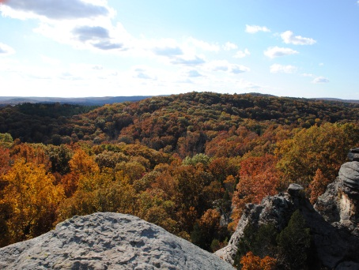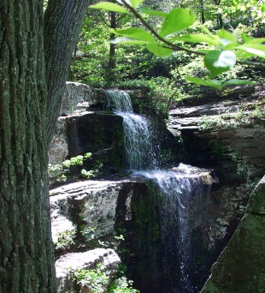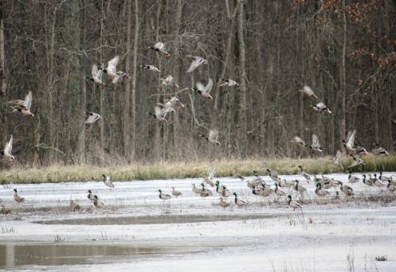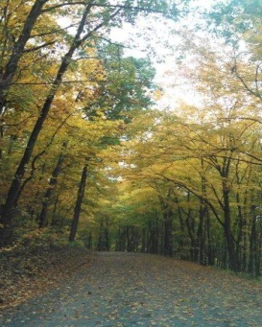

“Caring for the Land and Serving People”

OUTREACH NOTICE

FORESTRY TECHNICIAN

(RECREATION TECHICIAN)

GS-0462-5
The Shawnee National Forest will soon be advertising a GS-0462-5 Recreation Technician position. The position is a permanent full-time appointment, with the duty station in Vienna, IL. The purpose of this Outreach Notice is to inform prospective applicants of this opportunity

Anyone interested is encouraged to complete the attached
Outreach Response Form. You will still need to apply for the job separately.

Please respond to this outreach by November 26, 2014.

Recreation Technician Position:
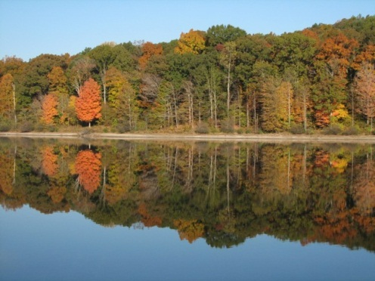
The position provides recreation support and serves as a Recreation Technician, working predominately in developed & dispersed recreation management. The primary duties include the operations and maintenance of developed recreation areas, such as campground, picnic areas, and trailheads; in addition, dispersed campsites in wilderness and non-wilderness areas. The position will serve as a Collection Officer, Chainsaw Operator (minimum qualification Class A), and a Forest Protection Officer with responsibility in enforcement of laws and regulations associated with forest and recreation use. The position serves as an inspector for recreation permits, which may include concession operations, outfitter/guide permits, and recreation events.

During the off-season, the incumbent may continue working independently, or with other employees, on resource protection/inventory/survey and data entry projects. The incumbent has responsibility for maintaining district recreation equipment and facilities, and has some administrative duties such as timekeeping, travel, seasonal employee work scheduling, and developing employee training plans and orientation.
The incumbent will perform safety hazard analyses of public recreation use areas, and takes, or recommends, corrective action.

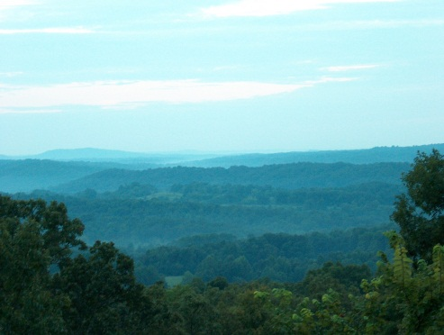
In wilderness areas, the incumbent will ensure areas are operated, used, and maintained in accordance with the Forest Service Wilderness Policy.
The incumbent will provide detailed information about recreation opportunities to Forest visitors, and explains Forest Service rules and regulations, including information on resource management practices and current conditions.
The incumbent may be assigned to other resource management duties, including fire management, as skill level, conditions and funding warrant. The incumbent may be assigned duties in trail maintenance and construction projects. During the height of the recreation season, April – October, the incumbent will work on weekends, including holidays, on a rotating schedule with other recreation staff.

The selected individual will be subjected to a background investigation conducted by the Department of Homeland Security.

Description of the Forest:

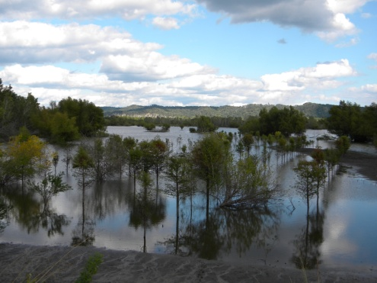
The Shawnee National Forest includes about 280,000 acres of National Forest System land and is the single largest publicly owned body of land in the State of Illinois. Within those lands, one can find the following:
- Seven Congressionally-designated Wilderness Areas (about 10% of the Forest)
- Six candidate Wild and Scenic Rivers
- Four National Natural Landmarks
- Four heritage resource sites on the National Register of Historic Places
- Two National Scenic Byways (NSB)
  - Great River Road NSB, extending along the Mississippi River
  - Ohio River NSB, along the Ohio, where it begins in Pennsylvania, traveling to Cairo, Illinois, where the Ohio meets the mighty Mississippi
- 80 designated Natural Areas considered important for botanical, ecological, geological or zoological reasons (about 5% of the Forest). Ten of these natural areas are designated by the Forest Service as Research Natural Areas (9 ecological areas and 1 botanical area) to focus research on these high value ecological sites.
  - 56 ecological areas
  - 14 botanical areas
  - 3 geological areas
  - 14 zoological areas
The Forest sits at the confluence of the Mississippi and Ohio Rivers and is rich in history, reflecting the pioneer movement of Americans into the west. Although predominantly oak-hickory, pine was planted in many areas in the past. Swamps contain tupelo and cypress communities. Razorback ridges associated with the Ozark upthrust are found on the west side of the Forest; the broader ridges associated with the Shawnee hills are found on the east side of the Forest. The Wisconsin glacier stopped north of the Shawnee, so the Grand Prairie (and its corn fields) most associated with the state of Illinois starts 40 miles north of the Forest.

The Shawnee is located within a day's drive (350 miles) of more than 45 million people, or 17% of the U.S. population (U.S. Census Bureau, 7-1-97 estimate). Additional information about the Forest may be found at the Shawnee National Forest website.
Climate:

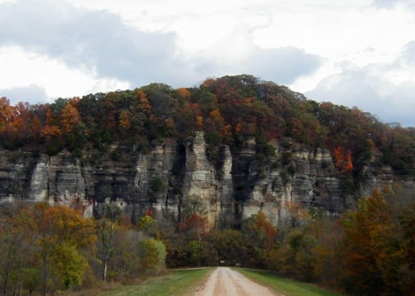
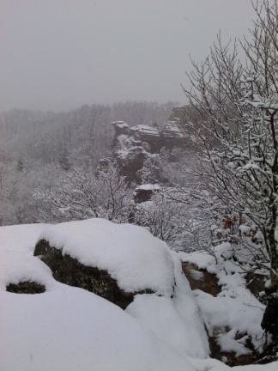
One can experience all four seasons in the southern Illinois region with an average of 3” of snow per year and temperatures rarely below 0 degrees. Summer days are sunny and humid with highs in the 80’s – 90’s, occasionally topping 100. Spring weather can occur in March, and fall weather can extend into November. During the spring and fall seasons, the climate and beauty of the area is especially compelling. Spring brings an abundance of blooming dogwoods, redbuds and wildflowers. The fall is saturated with color, as the leaves turn brilliant reds, gold and yellows. Garden of the Gods, the most visited site on the Forest, is a must-see during the fall color season. The unusual rock formations, coupled with the surrounding Garden of the Gods Wilderness, portray the beauty of southern Illinois at its finest.

Education:
Pre-schools through high schools can be found in most communities and rank high in the state. There are several community colleges in the area offering quite reasonable in-district tuition. Southern Illinois University, located in Carbondale, IL, offers a full range of baccalaureate through doctoral programs. Day care facilities also are available in most communities.

Churches:

Churches representing all major denominations can be found in communities across the region.

Economy:

Real estate in the area is moderately priced. The median price for purchasing a home is approximately $120,000, and house rentals begin at approximately $450 per month. Utilities are also priced moderately. Tourism is a developing economic force in the area. In recent years, several wineries have opened, offering two outstanding wine trails. Local breweries are also starting to emerge, adding to the tourism opportunities in the region.
With a mix of communities and towns, varying in population, Southern Illinois offers a rural environment with easy access to all possible amenities. Both shopping and entertainment opportunities are abundant within the area. Marion and Carbondale, IL along with Paducah, KY, offer shopping malls, movie theaters and several locally owned and operated restaurants along with major chain and fast-food restaurants. Additional information on local employment opportunities can be found at the following links:

Harrisburg, IL – Companies and Businesses
Marion, IL – Companies and Businesses
Carbondale, IL – Companies and Business
Healthcare:

Healthcare facilities serving the area include full facility Harrisburg Medical Center (Hospital), Carbondale Doctor’s Memorial Hospital and Marion Memorial Hospital. Services at these hospitals include cardiac units, oncology and neonatal units. Other hospitals providing care are Lourdes and Western Baptist Hospital in Paducah, KY and Deaconess in Evansville, IN. All the hospitals provide 24-hour emergency room physician coverage and specialists.

Recreational and Cultural Activities:

Whether you’re a barbecue fan, blues lover, outdoor recreational enthusiast, lover of small town life or big city adventurer, southern Illinois truly provides something for everyone in terms of social engagement opportunities and overall choice of recreational/cultural type activities.
With the perfect mix of small to mid-sized towns across the region coupled with easy access to bigger cities, including St. Louis, MO (located about 2 hours from Harrisburg, IL), Nashville, TN (located about 2.5 hours from Harrisburg, IL) and Chicago, IL (located about 6 hours from Harrisburg, IL), residents will find the ability to immerse themselves in the rich cultural and natural heritage encompassed in the area while also being able to easily travel and explore larger metropolitan areas nearby.
Festivals, fairs, artisan type craft events and more abound annually, and from more traditional American fare to Cuban, Thai, Japanese and more, a variety of restaurants representing global cuisine choices can be found across the region. Other opportunities, including concerts, theater engagements, etc, can also be discovered at a variety of events and locations, offering easy access to diverse recreational and cultural activities while also offering a beautiful, predominantly agricultural based area to call home.
To learn more about the area, please visit the following:
Marion, IL Chamber of Commerce
Saline County, IL Chamber of Commerce
Saline County, IL Tourism
Southernmost Illinois Tourism Bureau
Williamson County, IL Tourism Bureau

Non-Discrimination Statement
The U.S. Department of Agriculture (USDA) prohibits discrimination in all its programs and activities on the basis of race, color, national origin, age, disability, and where applicable, sex, marital status, familial status, parental status, religion, sexual orientation, genetic information, political beliefs, reprisal, or because all or part of an individual’s income is derived from any public assistance program. (Not all prohibited bases apply to all programs). Persons with disabilities who require alternative means for communication of program information (Braille, large print, audiotape, etc.) should contact USDA’s TARGET Center at (202) 720-2600 (voice and TDD). To file a complaint of discrimination, write USDA, Director, Office of Civil Rights, 1400 Independence Avenue, S.W., Washington, D.C. 20250-9410, or call (800) 795-3272 (voice) or (202) 720-6382 (TDD). USDA is an equal opportunity provider and employer.

Outreach Response Form

If you are interested in these positions, be sure to respond to this outreach by November 26, 2014 in one of three ways:

E-mail: akunzmann@fs.fed.us Fax: (618) 658-1300
Mail: Amanda Kunzmann
Shawnee National Forest
602 North First Street
Vienna, IL 62995

Respondents will be notified via email when the vacancy announcement becomes available.

For additional details on the position, you may call Brian Bourne, Trails & Developed Recreation Supervisor, at (618) 658-1303.

By completing this form, you are indicating that you are interested in the following position:
• Office Automation Clerk, GS-0326-3 Permanent Full-time position.

Location:
• Region 9, Shawnee National Forest, Vienna, Illinois
PERSONAL INFORMATION:
Name |  | Date
Address
City |  | State
Zip |  | E-Mail
Phone number(s)
Are you currently a federal employee
If Yes, current agency and location
current title/series/grade
Type of Appointment if Current  Government Employee |  |  | Permanent |  |  | Term | Temporary
Type of Schedule if Government  Employee |  |  | Full-time |  |  | Part-time | Intermittent
If you are not a current permanent (career or career conditional) employee, are you eligible for appointment under any of the following special authorities (check the appropriate box):
 | Person with Disabilities
 | Veteran’s Recruitment Act
 | Former Peace Corps Volunteer
 | Disabled Veteran with 30% Compensable Disability
 | Pathways Program (Students & Recent Graduates):
 | Veterans Employment Opportunities Act of 1998
 | Other, please describe:

