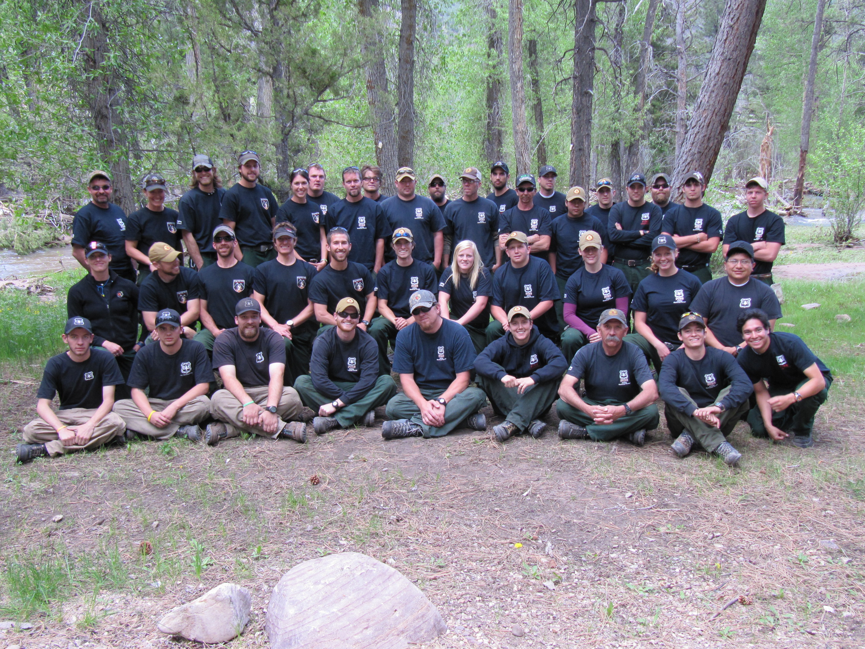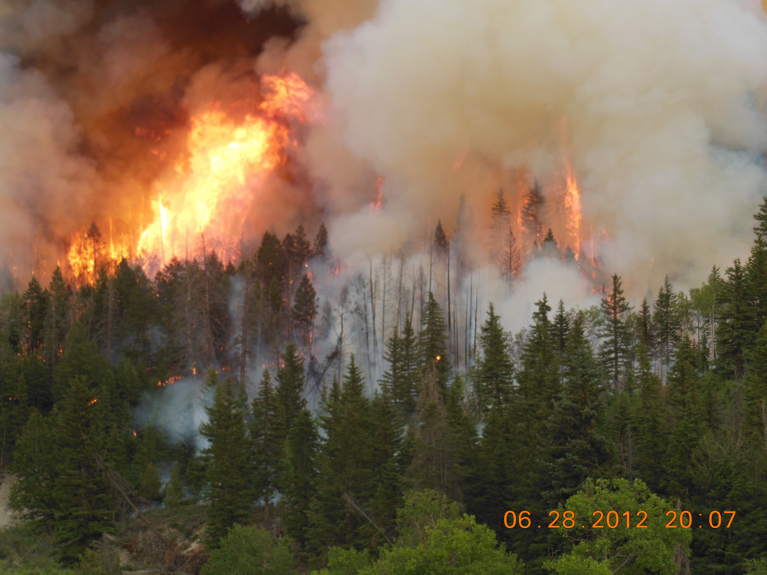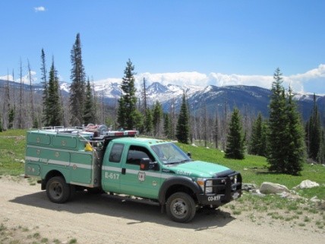

Ashley National Forest
Seasonal Employment Outreach
Wildland Firefighter Positions 2015

The Ashley National Forest will be filling seasonal wildland firefighter positions for the 2015 fire season. The fire positions will be located on Duchesne, Vernal, and Flaming Gorge Ranger Districts. Months of employment will be late May-August/September (Fire season).

Housing: Seasonal government housing facilities are available at Duchesne (Stockmore Guard Station) and Duchesne bunkhouse, Manila, and Dutch John. There is no seasonal government housing in Vernal.

The vacancy announcements for these positions will be posted on the United States Forest Service official website for application submittal: https://www.usajobs.gov/ . You must select one or more of the following duty stations when applying to be considered for our positions (Duchesne, Dutch John, Manila, Vernal). The following vacancies will only be open for 7 days. You must apply during these 7 days to be considered.

These are specific vacancy announcements for the Ashley National Forest FIRE seasonal positions listed below. Those that wish to be considered for available positions must apply to the corresponding announcement number during the date range listed below. All applicants who have applied to announcements within the set dates and are found to be qualified will be referred for consideration.

How to Apply
Applicants must apply online at www.usajobs.gov. You will be required to create a USAJOBS account and either create a resume or upload your own. Use the vacancy announcement numbers below to navigate to the appropriate position. Click “Apply Online” and follow the prompts to complete the online application. Remember you must select the duty station for the position you are applying for (Duchesne, Vernal, Dutch John, or Manila)

Required Documents
For a complete list of required documents, refer to the USAJOBS vacancy announcement.
- Resume that includes the following information: 1) job information for which you are applying; 2) personal information; 3) education; 4) detailed work experience; and, 5) other qualifications.
- College Transcripts if education is required for meeting basic qualifications and/or you are substituting education for specialized experience. An unofficial copy is sufficient with the application, however, if selected an official college transcript will be required.
- DD-214 and/or SF-15 Application for 10-point Veteran Preference if claiming Veterans’ Preference or eligibility for appointment under the VRA, VEOA, or 30% Disabled Veterans hiring authority.

Ashley National Forest Fire Management–Seasonal Positions 2015
Please contact local supervisors from the list below if you have questions

Description and  Announcement number | Duty Station | Supervisor
Forestry Aid (Firefighter)  GS-0462-03-Fire General  15-TEMP-R40462-3-FS-DT-PM  Apply: January 20-26, 2014 | Duchesne  Dutch John  Manila  Vernal | Lewis Rasband larasband@fs.fed.us o435-781-5233 c435-790-7083  Ben Sanders bensanders@fs.fed.us o435-781-5211 c435-790-7085  Zack Farmer zdfarmer@fs.fed.us o435-781-5267 c435-790-7073  Brodie Wilson bdwilson@fs.fed.us o435-781-5259 c435-790-7094  Chris Deets cdeets@fs.fed.us o435-781-5153 c435-790-5995  Gerald Knudson gcknudson@fs.fed.us o435-781-5214 c435-790-7081
Forestry Technician  GS-0462-04-Fire General  15-TEMP-R40462-4-FS-DT-PM  Apply: January 21-27, 2015 | Duchesne  Dutch John  Manila  Vernal | Lewis Rasband larasband@fs.fed.us o435-781-5233 c435-790-7083  Ben Sanders bensanders@fs.fed.us o435-781-5211 c435-790-7085  Zack Farmer zdfarmer@fs.fed.us o435-781-5267 c435-790-7073  Brodie Wilson bdwilson@fs.fed.us o435-781-5259 c435-790-7094  Chris Deets cdeets@fs.fed.us o435-781-5153 c435-790-5995  Gerald Knudson gcknudson@fs.fed.us o435-781-5214 c435-790-7081
Forestry Technician  GS-0462-05-Engine  15-TEMP-R40462-5-FEO-DT-PM  Apply: January 21-27, 2015 | Duchesne  Dutch John  Manila | Lewis Rasband larasband@fs.fed.us o435-781-5233 c435-790-7083  Zack Farmer zdfarmer@fs.fed.us o435-781-5267 c435-790-7073  Brodie Wilson bdwilson@fs.fed.us o435-781-5259 c435-790-7094  Gerald Knudson gcknudson@fs.fed.us o435-781-5214 c435-790-7081
Forestry Technician  GS-0462-05- Hand Crew  15-TEMP-R40462-5-HS-DT-PM  Apply: January 14-20, 2015 | Duchesne  Vernal | Ben Sanders bensanders@fs.fed.us o435-781-5211 c435-790-7085  Chris Deets cdeets@fs.fed.us o435-781-5153 c435-790-5995
Logistic Dispatcher  Apply: | Vernal | Dirk Huber dhuber@fs.fed.us o435-781-5172 c435-790-7087

Firefighting:
Seasonal jobs as wildland firefighter will include positions on either a local engine crew or hand crew. You will primarily be assisting in fire suppression, prevention, and natural disaster relief. Day to day projects may include thinning of timber, trail building/repair, fencing, and other strenuous jobs. Firefighting assignments may often last 2-3 weeks in duration. Shifts may be as long as 16 hours a day and overtime of 60+ hours a week. These assignments are usually performed in primitive, backcountry conditions where it is essential that firefighters be in top physical condition. Applicants must be 18 years of age by the date of hire. Employees and prospective applicants must annually pass the Work Capacity Test (WCT; 3 mile walk in 45 minutes carrying 45 lbs.). The Forest Service will provide all training, as well as Personal Protective Equipment (PPE) clothing, hardhat, fire shelter and line pack. Individuals shall provide full leather, eight inch tall boots, with lug soles. For more information on wildland firefighting check out:
http://www.fs.usda.gov/detail/r4/jobs/?cid=STELPRDB5354175

Logistics Dispatcher:
This position serves as a Logistics Support Dispatcher located in a dispatch center. This may be a single agency dispatch office or interagency dispatch center. The area covered may include federal, state and private lands within the dispatch center’s area of influence. The center is to respond to all-hazard incidents as needed or directed. The employee is responsible for serving as a dispatcher in support of fire suppression activities, but may also provide dispatch in response to all-risk incidents as needed or directed. The primary purpose of this position is to provide a wide range of logistical and administrative support functions. This position does not perform initial attack fire dispatch duties on a regular recurring basis.

About Ashley National Forest
The Ashley National Forest encompasses almost a million and a half acres in northeastern Utah and southwestern Wyoming. The Forest lies in three geographical areas: the east-west range of the Uinta Mountains, the Wyoming Basin, and the Tavaputs Plateau. Elevations range from 6,000 feet to 13,528 feet.
Steep canyons, high mountain peaks, glaciated basins, large open meadows, and desert badlands, all contain a rich diversity of vegetation and wildlife. The grasses and shrubs of the high mountain desert are replaced by pinyon and juniper as the elevation rises. In mid-elevation areas, aspen dominates and becomes mixed with conifer. Higher up, the vegetation changes to conifer forest composed of ponderosa pine, lodgepole pine, fir, and spruce. Grasses, forbs, and stunted, twisted conifers called krumholtz are found above timberline. Wildlife is abundant. Larger species include black bear, mountain lion, moose, elk, mule deer, pronghorn antelope, mountain goats, and bighorn sheep.
The Ashley has three major recreation attractions of national significance:
The High Uintas Wilderness, established by Congress in 1984, comprises of nearly one-half million acres in the Wasatch-Cache-Uinta and Ashley National Forests. Within the wilderness, elevations range from 8,000 feet to 13,582 feet at the top of Kings Peak, the highest mountain in Utah. The Uinta Mountain range runs east to west, from the Wasatch Mountains into Colorado. Pre-Cambrian rock formed from sediments laid down 600 million years ago makes up the core of the range. Glacial activity carved deep canyons and left a spectacular landscape of rolling, treeless peaks and stratified ridges interspersed with broad meadows and numerous lakes. The mountains below timberline are covered by coniferous forest, and meadows have streams and lush vegetation. The Wilderness is accessible from June through October, via numerous trails.
The Flaming Gorge National Recreation Area lies in the northeast part of the Forest. Flaming Gorge Reservoir extends almost 90 miles into Wyoming, and offers outstanding fishing and boating opportunities. Record-breaking German brown trout and large lake and rainbow trout have been taken from its waters.
The Green River below Flaming Gorge Dam is a world-famous blue-ribbon trout stream. The Little Hole National Recreation Trail parallels the river 7.3 miles from the Dam to the Little Hole Recreation Complex. Rafting this section of the Green River is a favorite pastime of visitors. Flaming Gorge Dam and Red Canyon Visitor Centers have exhibits to acquaint visitors with the area. At Ute Lookout Tower, the only lookout tower in the State of Utah, visitors can enjoy a spectacular view and learn about the life of early Forest Service lookouts. The Flaming Gorge National Recreation Area has three marinas and many campgrounds, some of which are open year-round.
Sheep Creek Geological Area is located about 5 miles south of Manila, in the Flaming Gorge National Recreation Area. Sheep Creek Canyon is filled with twisted and folded rock formations that expose 600 million years of the earth's history. Towering rock spires flank the road.

More specific information about the local cities/towns can be found at the following websites:

About Manila, Utah http://www.manilautah.com/
About Dutch John, Utah http://www.daggettcounty.org/index.aspx?NID=57
About Vernal, Utah http://www.utah.com/cities/vernal.htm
About Duchesne, Utah http://duchesne.utah.gov/

