to be
?
the

ASSISTANT RANGER FOR RECREATION
GS 101, 401 - 11

White Mountain National Forest

Androscoggin Ranger District

Wouldn’t you like

to be
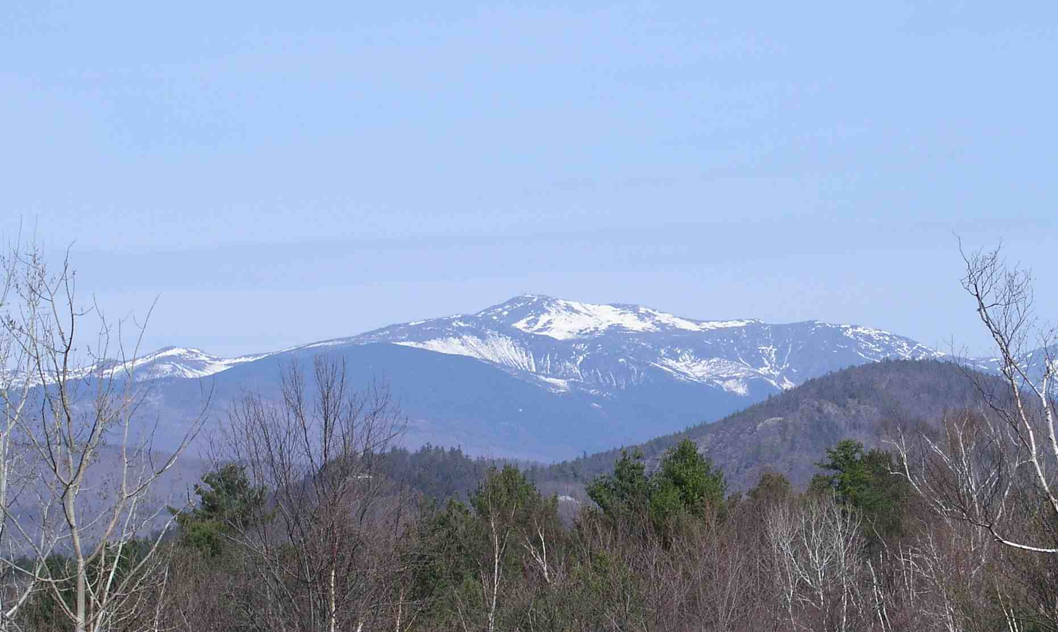
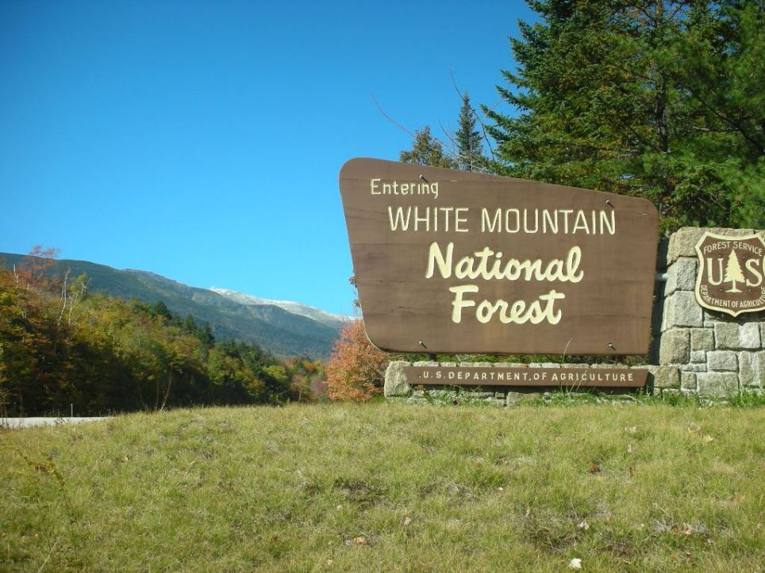
Well, now you can!

Outreach Notice
Please respond by October 10, 2014

White Mountain NF, Androscoggin R.D.

ASSISTANT RANGER (Recreation/Wilderness/Trails, etc.)
GS 101, 401, -11

Coming Soon! To an OPM website near you!!! An exciting job opportunity in Gorham, New Hampshire on the White Mountain National Forest. Home of…
- Mt Washington and the Northern Presidentials
- One of the busiest forest recreation programs in Region 9
- Hundreds of miles of trails and an extensive backcountry program
- The Great Gulf, Wild River, and Caribou-Speckled Mountain Wildernesses
- The Mount Washington Avalanche Center
- The easternmost ranger district in the United States
- An energetic, highly motivated, and youthful (at heart) staff
- Great partners
- Real mountains with breathtaking views
- The foliage capital of the United States
- Working on a district that includes both New Hampshire and Maine
- Patriot and Red Sox games on local TV!!!

All this can be YOURS, plus the pleasure of living and working with an enjoyable group of New England Yankees and would-be Yankees in the backyard of liberty.

About the job:
GS-101/401-11 Assistant Ranger (Recreation/Wilderness) position in Gorham, New Hampshire. We are looking for a bright energetic person with good people and team skills and the ability to run a complex recreation operation, including active and challenging VIS, Wilderness, and backcountry programs. The program management activities include developed recreation (five campgrounds comprising 231 total campsites); management of the Great Gulf, Wild River, and Caribou-Speckled Wildernesses; oversight of the Mount Washington Avalanche Center (the only forecasting center east of the Mississippi); accountability for a recreation fee program; multiple front country and backcountry dispersed sites and trailheads, over 450 miles of trails (hiking, Nordic skiing, and snowmobile), including 53 miles of the Appalachian Trail; and a VIS program including a large interpretative area located in the Androscoggin district office. The job also includes oversight of district fleet, facilities, heritage, recreation and non-recreation special uses, and numerous partnerships including the Appalachian Trail Conservancy, the Appalachian Mountain Club, and the Randolph Mountain Club.

The position requires someone with the ability to: (1) be a strong leader, supervisor, mentor, and role model for a dynamic group of permanent and seasonal employees, (2) coordinate effectively with partners, clubs, town governments, and other agency officials, (3) work well in a team environment at both the Forest and District levels, as a team leader and a team player, (4) work effectively with a diverse and well-informed citizenry, (5) have strong NEPA skills, (6)multi-task, and (7) respond with wisdom to the wide variety of challenges and opportunities that crop up daily on a busy Ranger District on a scenic and highly visited National Forest.

For more information or to express interest please contact Jake Lubera who will be leaving the position at the end of September at (603) 466-2713x224, email: jlubera@fs.fed.us or District Ranger Katie Stuart at (603)466-2713x210, email: kstuart@fs.fed.us

DISTRICT & FOREST INFORMATION

The Androscoggin Ranger District is located in Coos County, New Hampshire, and Oxford County, Maine. The office is in Gorham, New Hampshire, and was built in 1996. The WMNF is visited by over 7 million people each year, and is considered one of the Northeast’s crown jewels. Our visitors and local communities have a long history of caring for the forest in the White Mountains: they were the driving force behind the 1911 Weeks Act, under which the WMNF was purchased. This strong interest in the management of these lands continues today, and is demonstrated through the substantial number of partnerships and cooperative agreements that exist on the Forest.

The Presidential Range of the White Mountains offers a stunning alpine backdrop to the quiet villages in the river valleys of northern New Hampshire and western Maine. Outdoor sports opportunities are endless while our scenery is unsurpassed. The phrase "If you don't like the weather, wait a minute, it'll change," was created in New England. Northern New Hampshire and western Maine have a history of bizarre and unpredictable weather patterns. The summit of Mount Washington is the official home of "The World's Worst Weather", where the highest wind speed ever recorded in the northern hemisphere was documented at 231 miles per hour. In general, there are four distinct seasons with snowy, sparkling cold winters, wet and muddy springs, relatively cool summers, and glorious falls. Tuckerman Ravine is well known for extreme skiing in the spring, and Huntington Ravine is well known for ice climbing. Access to both areas requires fairly arduous hikes of over 3 miles from the nearest year-round road, and our snow ranger program provides avalanche forecasting for these two destinations.

Recreation activities, facilities, and programs on the District include: five fee campgrounds (four of which are managed by concession); three Wilderness areas; numerous day use areas; extensive dispersed backcountry and Wilderness camping; over 460 miles of four-season trails (including 52 miles of the Appalachian Trail) that receive various uses including hiking, snowmobile, snowshoe, cross-country skiing, and mountain bike use; rock and ice climbing; several swimming areas; a network of backcountry shelters and tent sites; and several National Register historic sites.

COMMUNITY INFORMATION

Gorham has a population of about 3,100 and the nearby city of Berlin has a population of about 11,800. The economy of the area is split between recreation and forest products. Gorham is generally thought of as a recreation community and Berlin as industrial. Both communities recognize the value of a “working forest” to provide a variety of needs for the public. A new biomass mill complex is located within the Berlin area. Both Gorham and Berlin have public schools through high school. Nearby Bethel, Maine, hosts a private high school. Berlin also hosts a branch of the College for Lifelong Learning affiliated with the University of New Hampshire, and the White Mountain Community (Technical) College. Hospital facilities are located in Berlin while Gorham hosts a medical clinic. There are several banks and credit unions in the area. Cable television is available in towns but may not be available in some of the more rural areas. Churches for just about every Christian denomination are present but places of worship for other faiths are absent. There is diversity among the predominantly Caucasian population with French being a common language, especially in Berlin.

New Hampshire is the "Live Free or Die" State, but it isn't completely free. There are NO STATE INCOME OR SALES TAXES. To make up for that, property taxes can be quite high. Each community is different, so checking them out can be a deciding factor when buying a home. Houses in the area rent for about $300 - $800 per month and sell for $60,000 to $200,000+. There are numerous homes for sale in the area and with patience, excellent buys can be found.

The White Mountain Region is a four season recreation destination. Recreational opportunities are numerous, including summer activities of camping, hiking, climbing, horseback riding, fishing - both lakes and rivers, boating, swimming, surfing - the Atlantic Ocean is a short drive (about 2 hours), wildlife watching, tax-free shopping, picnicking, the arts and other forms of entertainment too numerous to mention. During the winter months, hunting, downhill and cross-country skiing, snowmobiling, winter mountaineering, ice climbing and other winter sports are popular. There are many winter ski resorts within easy driving distance of Gorham including Wildcat, Attitash-Bear Peak, Bretton Woods, Sunday River, and Cannon Mt. Extensive backcountry skiing can be found above treeline across the Presidential Range, and includes the famous steep bowl of Tuckerman Ravine. Several world class Nordic centers serve cross-country skiers including: Jackson Ski Touring, Great Glen Trails, Bretton Woods, Bear Notch, and Mt. Washington Valley Ski Touring.

OUTREACH REPLY
Please respond by October 10, 2014

ASSISTANT RANGER FOR RECREATION
GS - 101, 401-11

White Mountain National Forest
Androscoggin Ranger District

Name: ________________________________________________________

Current Duty Station/ Forest/ Region or Agency if other than USFS: _______________________________________________________________

Current Title/Series/Grade: ________________________________________

Mailing Address: ________________________________________________
________________________________________________
________________________________________________
________________________________________________

Telephone: ________________________________________________

Email address: ____________________________________________

You will be automatically mailed a copy of the position advertisement if you reply to this outreach.

Please return this form to Katie Stuart, District Ranger at kstuart@fs.fed.us, or fax (603) 466-2856. Reply may also be mailed to USDA Forest Service, ATTN District Ranger, 300 Glen Road, Gorham, NH 03581

