Allegheny National Forest
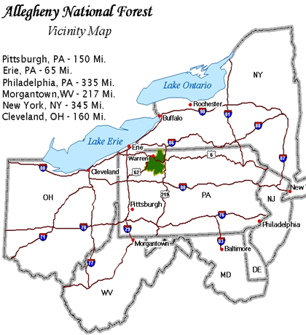
Outreach Notice
GS-0462-5/6 Forestry Technician (Timber Sale Preparation)
Duty Station: Bradford, PA and Marienville, PA

Outreach Closes: October 3, 2014

Please return the completed outreach response found on the last page of this notice.

The Allegheny National Forest is conducting an outreach for multiple Forestry Technicians (Timber Sale Preparation) on both districts. The purpose of this Outreach Notice is to determine the potential applicant pool for this position and to establish the appropriate recruitment method and area of consideration for the advertisement (e.g. technical or professional series, target grade or multi-grade and government-wide or DEMO).

This outreach will be updated with the Vacancy Announcement numbers and link to USAJobs when they are available.

The duties of the Forestry Technician (Timber Sale Preparation) position include:

GS-5 Forestry Technician position information (GS-0462-05)

Independently applies silvicultural prescriptions and marking guides to designate timber for harvest. Brings to the attention of responsible individuals situations on the ground that are inconsistent with guidelines. Acts as a certified timber cruiser. Independently applies the instructions issued in a cruise plan. Takes and records tree measurements, assesses quality, and determines defect. Prepares and processes cruise data on a computer. Observes and reports areas of possible archeological significance, and sightings of sensitive, threatened or endangered wildlife species. Traverses harvest unit boundaries, road locations, and determines area with the use of a GPS unit. Participates in other aspects of resource management support work such as recreation, maintenance, silviculture, tree planting, etc.

GS-6 Forestry Technician position information (GS-0462-06)

Conducts timber cruises and surveys within varying stand conditions to locate and estimate the quantity of timber on a given area, according to species, type, and quality. Selects and marks trees to be harvested or left uncut; estimates volume, defect, and quality of timber in a given area. Measures and defects timber on the ground using maps and written cruise plans provided by an advanced cruiser that explain sampling intensity, plot locations, type of cruise and any special instructions. Lays out boundaries of cutting areas as outlined in the NEPA, considering variables such as accessibility, steep slopes, stream protection, nesting tree protection, wildlife impacts, fuels management and regeneration requirements. Brings to attention of responsible individual situations where specific prescriptions do not fit ground conditions. Marks trees using marking rules in areas complicated by variations in type, species composition, defect, site, age, class, etc. Prepares area maps, marks unit boundaries and occasionally uses GPS to record boundary locations. Is able to follow clear direction given by supervisor or other senior personnel and implement it efficiently, producing high quality outcomes that meet Regional standards. Summarizes cruising and marking data and prepares reports and topographic maps indicating quantity of timber, condition of area, difficulties to be encountered, etc.

For questions regarding the duties of this position please contact:
Stacy Stratton at stacystratton@fs.fed.us, 814.927.5758

QUALIFICATION REQUIREMENTS for this position can be found in the Office of Personnel Management (OPM) Operating Manual for Qualification Standards for General Schedule Positions, which is available from any Federal Government Personnel Office and OPM on their web site (http://www.opm.gov/qualifications/index.asp).

How to Apply: Individuals that wish to be considered for this position must respond to this outreach and/or apply to the vacancy announcement on USAJOBS.gov website by the closing date of the vacancy announcement. The announcement numbers have not been generated at this time. To be notified when announcements are posted send the completed form from the last page of this document including contact information to Joe Gomola. Once announcements are posted applicants must apply online at www.usajobs.gov. The Referral List for this position will be issued to the selecting official upon closing of the vacancy announcement. All applicants found to be qualified, and in the quality group will be referred for consideration. This outreach will be updated with the Vacancy Announcement numbers and link to USAJobs when they are available.

Once in USAJOBS.gov applicants will be directed how to apply by submitting their profile information in USAJOBS. Interested applicants can set up a profile in USAJOBS before the announcement is posted that will enable them to receive an email when the announcement is posted. Applicants can also set up an alert on USAJOBS.gov citing the Series/Location and grade that will also notify them when the announcement is posted.

ALLEGHENY NATIONAL FOREST

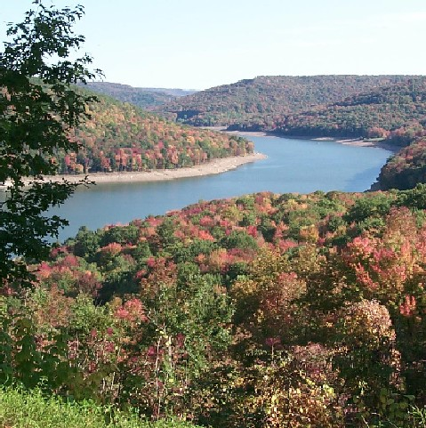
The Allegheny National Forest is headquartered in Warren, Pennsylvania and has two Ranger Districts. The Marienville Ranger District is located in Marienville, PA and the Bradford Ranger District is located in Marshburg, PA. The 513,000-acre Forest is the only national forest in Pennsylvania and lies within a day’s drive of 1/3 of the Nation’s population. It includes two Wilderness areas, two National Scenic Areas, two National Wild and Scenic Rivers, and the Tionesta Research Natural Area (the largest contiguous tract of old growth forest in Pennsylvania). A variety of recreation activities include boating, camping, hunting, fishing, ATV riding and snowmobiling that result in about 4 million recreation visitor days annually. The 12,000-acre Allegheny Reservoir provides boating, camping, and fishing opportunities. Roughly, 1/3 of the world’s supply of black cherry furniture veneer is grown on the Allegheny National Forest, resulting in a profitable timber program. Abundant fish and wildlife provide a variety of hunting, fishing, and viewing opportunities. The changing colors of the hardwood leaves each fall provide spectacular views.

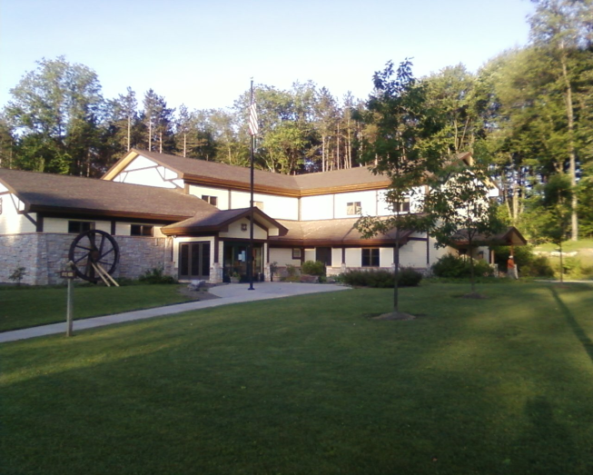
MARIENVILLE COMMUNITY

Marienville is a small rural community with about 600 residents located in NW Pennsylvania in the southern part of the Allegheny National Forest. The Marienville Ranger Station, constructed in 2005, is an attractive and spacious office located north of the community. While there are limited services within the community; it does have a K-12 school, community center and swimming pool, library and a number of churches. In addition, the community has two small grocery stores, hardware store, pharmacy, satellite clinic, motels, restaurants and a gas station/convenience store.

SURROUNDING COMMUNITIES

The Surrounding communities of Bradford (54 miles), Clarion (33miles), Kane (24 miles), Ridgway (32 miles), Tionesta (33 miles), and Warren (32 miles), are all within a 30-50 minute drive. The area’s climate provides a classic display of the four distinct seasons. Summers are warm and moderately humid with average temperatures of 75-80 degrees. Fall provides panoramic views as the foliage turns spectacular colors of yellow, reds and purples. Springtime brings alive the many blooming wild flowers and other natural vegetation. The winters are moderate with average temperatures of 20-25 degrees. Annual precipitation is about 40 inches.

Bradford, Kane Warren and Clarion each have a general hospital, with several medical clinics, ambulance service, physicians of all specialty areas, dentists and nursing homes throughout the region. There are motels, radio stations, city and county offices and local retail businesses. Recreation facilities include baseball and soccer fields, all-weather track, tennis courts, health and fitness clubs, an indoor and outdoor swimming pool, four 18-hole golf courses in Warren County alone and several parks. In the immediate vicinity are trout fishing, hunting, hiking, ATV trails, bicycling, camping, and wildlife viewing. The main industries are manufacturing, social services and retail. The nearest commercial airports to Marienville are in Bradford, PA (52 minutes), Jamestown, NY (82 minutes), Erie, PA (2 hours) and Pittsburgh, PA (2.5 hours).

The area’s educational opportunities consist of various elementary and high schools (K-12), and several satellite campus curriculums offered through the cooperative efforts of the Warren-Forest County Higher Education Council and Jamestown Community College. Within 30-90 minutes drive, you will find other major universities, such as Gannon in Erie, PA; and Edinboro University in Edinboro, PA, Clarion University in Clarion, PA; Penn State University-Dubois Campus in Dubois, Pa; University of Pittsburgh-Bradford Campus in Bradford, PA; Penn State University-Main Campus in State College, PA; and St. Bonaventure University in Olean, NY.

Housing costs are among the lowest in the nation. There are rentals available ranging between $300-$600/month. Rental homes and apartments range from $300-$600 per month for an average three bedroom home/apartment. The price of single family homes range from $40,000 and up, depending on where you live in the county. The average price is $61,000. Warren and Forest County residents are subject to real estate taxes computed by multiplying the property assessment by the millage rate. The total millage rate includes taxes for the county, the school district, and the local municipality. Property is assessed at half the market value.

For more information about the Forest and local communities, please visit the following websites.

- Allegheny National Forest.

- For the Bradford Ranger District:
  - McKean County - http://www.mckeancountypa.org

- For the Marienville Ranger District:
  - Elk & Forest County - http://www.pagreatoutdoors.com/

If you have questions, please contact Stacy Stratton at stacystratton@fs.fed.us or 814.927.5758. If you would like to be notified of the Vacancy Announcement when it's available, please complete the enclosed form and send via e-mail or fax. (See information on bottom of form)

The U.S. Department of Agriculture (USDA) prohibits discrimination on all its programs and activities on the basis of race, color, national origin, gender, religion, age, disability, political beliefs, sexual orientation, and marital or family status. (Not all prohibited bases apply to all programs.) Persons with disabilities who require alternative means for communication of program information (Braille, large print, audiotape, etc.) should contact USDA's TARGET Center at (202) 720-2600 (voice and TDD). To file a complaint of discrimination, write USDA, Director, Office of Civil Rights, Room 326-W, Whitten Building, 14th and Independence Avenue, SW, Washington, DC 20250-9410 or call (202) 720-5964 (voice and TDD). USDA is an equal opportunity provider and employer.

OUTREACH NOTICE
Allegheny National Forest
Respond to Stacy Stratton at stacystratton@fs.fed.us by October 3, 2014
Fax 814.927.2285

Position Title/Series/Grade: Forestry Technician (Timber Sale Preparation) GS-0462- 5/6

Duty Station: Bradford and Marienville

PERSONAL INFORMATION:

Name: Date:

Address: Phone No:

E-mail address:

WORK EXPERIENCE:

Are you currently a Federal employee? Yes No

IF YES: What is your Agency, Title, Series and Grade:

______________________________________________________________________________

Type of Appointment: Permanent Term Temporary

If you are not a current permanent (career or career conditional) employee, are you eligible for appointment under any of the following special authorities?
Person With Disabilities
Veterans Readjustment
Former Peace Corps Volunteer
Disabled Veteran w/30% Compensable Disability
Student Career Experience Program
Veterans Employment Opportunities Act of 1998
Other

Briefly describe why you will be a quality candidate for this position:

