INVASIVE SPECIES PRESENTATION
Hosted at the Crab Orchard National Wildlife Refuge
May 8th, 2014- 6:00 p.m.
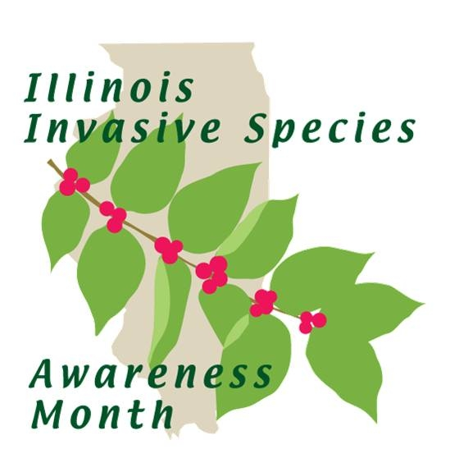
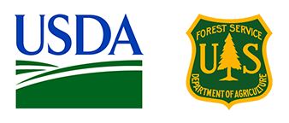
Presented by Karla Gage; River To River Cooperative Weed Management Area (CWMA) in cooperation with the Shawnee National Forest
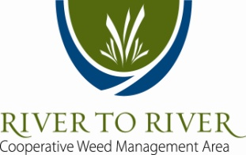
www.rtrcwma.org www.fs.usda.gov

