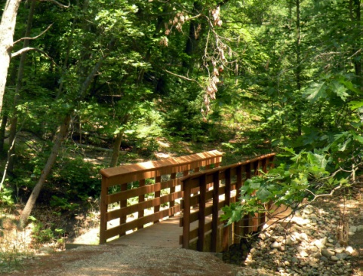
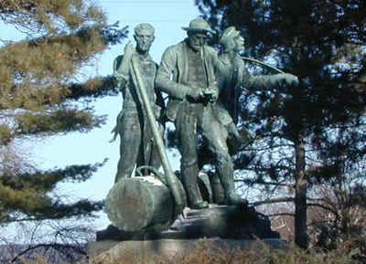
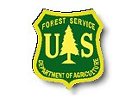
Announcement
The Huron-Manistee National Forests
Mio Ranger District & Huron-Shores Ranger District

2014 Seasonal Workforce Positions
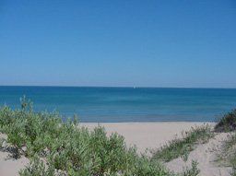
Vacant positions will be located on the Mio and/or the Huron-Shores Ranger Districts of the Huron-Manistee National Forests.
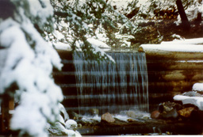

Length of season and number of positions will depend upon budget. Seasonal housing may be available for employees.

The vacancy announcements for these positions are posted on the USAJobs website found at www.usajobs.gov.

About the local areas:

The Huron-Shores Ranger District is located in Oscoda, Michigan at the mouth of the Au Sable River on the Lake Huron coast, has a population of approximately 8,000 and offers many amenities. Most shopping can be done locally but a larger metropolitan area (Bay City, Saginaw, and Midland) is located less than two hours away for those seeking expanded opportunities. The Oscoda community is home to churches of various denominations. Many civic and fraternal organizations are also available. The Oscoda Area Schools provide education in grades K-12 with Alpena Community College offering college courses locally. Doctors and dentists are available locally with hospitals located in Tawas (20 miles) and Alpena (45 miles). Outdoor recreation opportunities are abundant with great fishing, hunting, camping, hiking, and winter sports activities. Government housing may be available for a short-term basis within walking distance of the ranger station. More information about the Oscoda area can be found on the Oscoda web page at http://www.oscoda.com/. Please contact District Ranger Shawn Cochran at 989-739-0728 for specific information.

The Mio Ranger District Administrative Site is a multi-million dollar office and warehouse facility built in 2006. The new facility is comprised of a two story office building, a climate controlled warehouse and workshop, and two fully enclosed barns for storage of supplies and equipment. Mio is 90 miles north of Saginaw, Michigan via I-75 and State Highway M-33. Located midway on the Au Sable River, the cities of Grayling and West Branch are 35 minutes away. Other communities in Oscoda County are McKinley, Comins, Fairview & Luzerne. The Oscoda County Library is located in Mio. Recreational activities in the area include hiking, swimming, camping, boating, canoeing, kayaking, tubing, hunting, motorcycle and ATV riding, snow-mobiling, ice fishing, and cross-country skiing. A nine-hole golf course is conveniently located 5 miles north of town and a 72-hole resort is only 20 miles distant. Please contact District Ranger Steve Goldman at 989-826-3252 for specific information.

Temporary 1039 Positions:

These are temporary seasonal positions not to exceed 1039 hours. This notification is being circulated to inform interested individuals of these current opportunities. In past years the vacancies have been advertised under Open Continuous Recruitment (OCR) bulletins that did not have closing dates. This process has changed. Applicants will now have to apply to specific Forest vacancy announcements.

- ONLY on-line applications are accepted through www.usajobs.gov.
- New applicants must create a new profile within USAJOBS.
- If you have previously applied for this position under old OCR numbers, you will need to re-apply with the new announcement numbers.

These positions will be advertised at www.usajobs.gov beginning April 21st, 2014.

Resource Program: Wildlife/Fisheries/General

General Duties: Travel to and from work sites. Working and hiking in variable weather conditions in remote locations on difficult terrain. Daily surveys to achieve forest management practices.
Typical Length of Season: May to October

Wildlife/Fisheries/General –Temporary Positions 2014
Announcement # | Description | Specific Job Duties
14-TEMP110904-038554JT-DT  OSCODA, MI or MIO, MI  (closes 4/25/14)  Contact Paul Thompson  989-739-0728 ext 3028  Contact Kim Piccolo  989-826-3252 ext 3334 | Biological Science Technician (Plants)  GS-0404-05 | Performs work concerned with the improvement of management practices to attain increase yield, improved quality, adaptation to mechanization, and resistance to diseases, insects, heat, drought, cold, or other hazards; and similar work usually concerned with higher plant life.
14-TEMP110904-038565JT-DT  OSCODA, MI or MIO, MI (closes 4/25/14)  Contact Paul Thompson  989-739-0728 ext 3028  Contact Kim Piccolo  989-826-3252 ext 3334 | Biological Science Technician (Plants)  GS-0404-06 | Performs work concerned with the improvement of management practices to attain increase yield, improved quality, adaptation to mechanization, and resistance to diseases, insects, heat, drought, cold, or other hazards; and similar work usually concerned with higher plant life.
14-TEMP110904-038573JT-DT  OSCODA, MI or MIO, MI (closes 4/25/14)  Contact Paul Thompson  989-739-0728 ext 3028  Contact Kim Piccolo  989-826-3252 ext 3334 | Biological Science Technician (Plants)  GS-0404-07 | Performs work concerned with the improvement of management practices to attain increase yield, improved quality, adaptation to mechanization, and resistance to diseases, insects, heat, drought, cold, or other hazards; and similar work usually concerned with higher plant life.

Grade | Hourly Rate
GS-1 | $9.84
GS-2 | $11.06
GS-3 | $12.06
GS-4 | $13.55
GS-5 | $15.15
GS-6 | $16.89
GS-7 | $18.77
WG-5 | $17.76
WG-8 | $20.66

INSTRUCTIONS ON HOW TO APPLY FOR TEMPORARY 1039 POSITIONS:

All federal job openings are listed by the Office of Personnel Management on the USAJOBS website at: http://www.usajobs.opm.gov/. To find Forest Service positions on this website, look under “Agency Search” for the Department of Agriculture and scroll down to “Forest Service.” For recruiting candidates for temporary positions, the Forest Service uses single location vacancies. You must apply by location of vacancy. Mio, MI for Mio Ranger District or Oscoda, MI for the Huron Shores Ranger District.

Look on the USAJOBS website for the vacancy announcement. Each vacancy will have a detailed description of the process to follow when applying for the job. You will notice the location for these positions shows as “Mio or Oscoda”. You must apply for each location separately.

Another method to view anticipated jobs opening with the Forest Service is the database found on this website https://hrm.gdcii.com/outreach/Default.aspx

