Shawnee National Forest

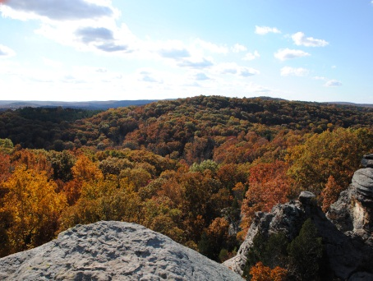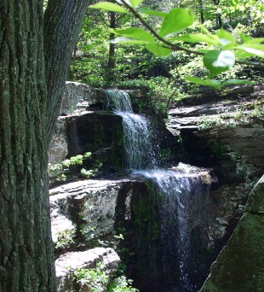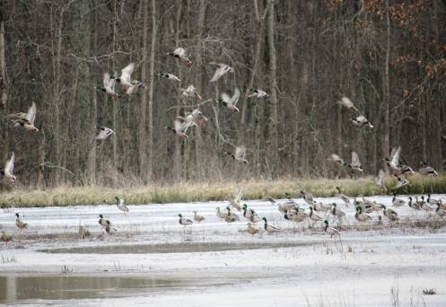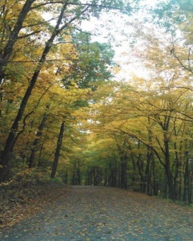

“Caring for the Land and Serving People”

OUTREACH NOTICE

GS-0462-4 Forestry Technician (Wilderness/Trails)

Temporary Not-To-Exceed 1039 hours

GS-0462-04
The Shawnee National Forest is seeking qualified applicants to fill a temporary not-to-exceed 1039 hours GS-0462-4 Forestry Technician (Wilderness/Trails) position. The position will be advertised in USAJOBS automated application system at USAJobs.

The purpose of this Outreach Notice is to inform prospective applicants of this opportunity.

Anyone interested is encouraged to complete the attached
Outreach Response Form by March 29, 2014.

THE POSITION:
The position is located in Jonesboro, Illinois and will serve as a Wilderness/Trail Crew Member. This position performs a variety of technical work in support of the Unit trails program. Work will primarily involve performing trail reconstruction and maintenance. Work will include working with a variety of hand tools and mechanized equipment. The work will be in an outdoor setting. Working outdoors may involve performing tasks in adverse weather conditions such as high heat and humidity, and requires moderate to strenuous physical exertion including walking in rugged/steep terrain, bending, lifting and carrying supplies for long periods of time. Crew members will be exposed to insects, poison ivy, animals and hot and/or rainy weather.
APPLICATION PROCESS:
This position will be posted on USAJobs, and applications will be processed through an on-line applicant assessment system that has been specifically configured for the USDA Forest Service.

Job Title: Forestry Technician (Wilderness/Trails)

Department: Department Of Agriculture Agency: Forest Service

Sub Agency: Shawnee National Forest
SALARY RANGE: | $13.55 hr
OPEN PERIOD: | 10 days
SERIES & GRADE: | GS-0462-04
POSITION INFORMATION: | Temporary, Full Time–Not-To-Exceed 1039 hours

PROMOTION POTENTIAL:
DUTY LOCATION: | Jonesboro, IL
OUTREACH DEADLINE:
The outreach deadline is March 29, 2014. Please fill out form below. The vacancy will come out later and will be posted in USAJobs.
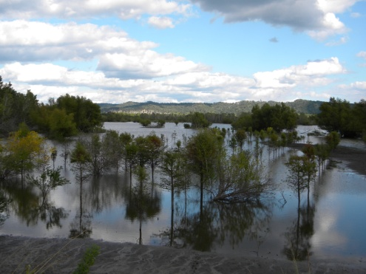

Description of the Forest:

The Shawnee National Forest includes about 280,000 acres of National Forest System land and is the single largest publicly owned body of land in the State of Illinois. Within those lands, one can find the following:
- Seven Congressionally-designated
- Wilderness Areas (about 10% of the Forest)
- Six candidate Wild and Scenic Rivers
- Four National Natural Landmarks
- Four heritage resource sites on the National Register of Historic Places
- Two National Scenic Byways (NSB)
  - Great River Road NSB, extending along the Mississippi River
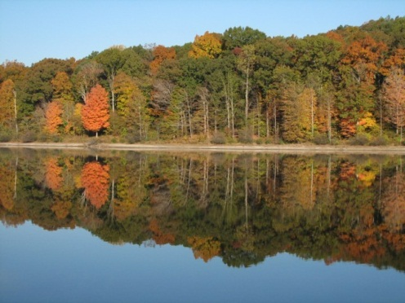
  - Ohio River NSB, along the Ohio, where it begins in Pennsylvania, traveling to Cairo, Illinois, where the Ohio meets the mighty Mississippi
- 80 designated Natural Areas considered important for botanical, ecological, geological or zoological reasons (about 5% of the Forest). Ten of these natural areas are designated by the Forest Service as Research Natural Areas (9 ecological areas and 1 botanical area) to focus research on these high value ecological sites.
  - 56 ecological areas
  - 14 botanical areas
  - 3 geological areas
  - 14 zoological areas
The Forest sits at the confluence of the Mississippi and Ohio Rivers and is rich in history, reflecting the pioneer movement of Americans into the west. Although predominantly oak-hickory, pine was planted in many areas in the past. Swamps contain tupelo and cypress communities. Razorback ridges associated with the Ozark upthrust are found on the west side of the Forest; the broader ridges associated with the Shawnee hills are found on the east side of the Forest. The Wisconsin glacier stopped north of the Shawnee, so the Grand Prairie (and its corn fields) most associated with the state of Illinois starts 40 miles north of the Forest.

The Shawnee is located within a day's drive (350 miles) of more than 45 million people, or 17% of the U.S. population (U.S. Census Bureau, 7-1-97 estimate). Additional information about the Forest may be found at the Shawnee National Forest website.
Climate:

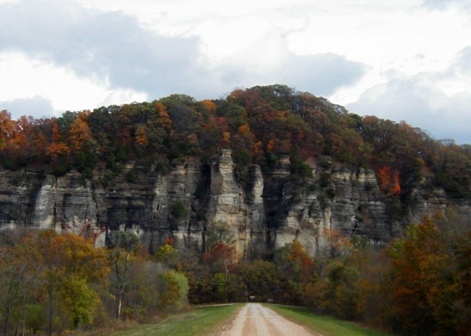
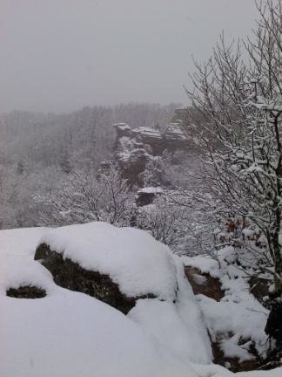
One can experience all four seasons in the southern Illinois region with an average of 3” of snow per year and temperatures rarely below 0 degrees. Summer days are sunny and humid with highs in the 80’s – 90’s, occasionally topping 100. Spring weather can occur in March, and fall weather can extend into November. During the spring and fall seasons, the climate and beauty of the area is especially compelling. Spring brings an abundance of blooming dogwoods, redbuds and wildflowers. The fall is saturated with color, as the leaves turn brilliant reds, gold and yellows. Garden of the Gods, the most visited site on the Forest, is a must-see during the fall color season. The unusual rock formations, coupled with the surrounding Garden of the Gods Wilderness, portray the beauty of southern Illinois at its finest.

Education:
Pre-schools through high schools can be found in most communities and rank high in the state. There are several community colleges in the area offering quite reasonable in-district tuition. Southern Illinois University, located in Carbondale, IL, offers a full range of baccalaureate through doctoral programs. Day care facilities also are available in most communities.

Churches:

Churches representing all major denominations can be found in communities across the region.

Economy:

Real estate in the area is moderately priced. The median price for purchasing a home is approximately $120,000, and house rentals begin at approximately $450 per month. Utilities are also priced moderately. Tourism is a developing economic force in the area. In recent years, several wineries have opened, offering two outstanding wine trails. Local breweries are also starting to emerge, adding to the tourism opportunities in the region.
With a mix of communities and towns, varying in population, Southern Illinois offers a rural environment with easy access to all possible amenities. Both shopping and entertainment opportunities are abundant within the area. Marion and Carbondale, IL along with Paducah, KY, offer shopping malls, movie theaters and several locally owned and operated restaurants along with major chain and fast-food restaurants. Additional information on local employment opportunities can be found at the following links:

Harrisburg, IL – Companies and Businesses
Marion, IL – Companies and Businesses
Carbondale, IL – Companies and Business
Healthcare:

Healthcare facilities serving the area include full facility Harrisburg Medical Center (Hospital), Carbondale Doctor’s Memorial Hospital and Marion Memorial Hospital. Services at these hospitals include cardiac units, oncology and neonatal units. Other hospitals providing care are Lourdes and Western Baptist Hospital in Paducah, KY and Deaconess in Evansville, IN. All the hospitals provide 24-hour emergency room physician coverage and specialists.

Recreational and Cultural Activities:

Whether you’re a barbecue fan, blues lover, outdoor recreational enthusiast, lover of small town life or big city adventurer, southern Illinois truly provides something for everyone in terms of social engagement opportunities and overall choice of recreational/cultural type activities.
With the perfect mix of small to mid-sized towns across the region coupled with easy access to bigger cities, including St. Louis, MO (located about 2 hours from Harrisburg, IL), Nashville, TN (located about 2.5 hours from Harrisburg, IL) and Chicago, IL (located about 6 hours from Harrisburg, IL), residents will find the ability to immerse themselves in the rich cultural and natural heritage encompassed in the area while also being able to easily travel and explore larger metropolitan areas nearby.
Festivals, fairs, artisan type craft events and more abound annually, and from more traditional American fare to Cuban, Thai, Japanese and more, a variety of restaurants representing global cuisine choices can be found across the region. Other opportunities, including concerts, theater engagements, etc, can also be discovered at a variety of events and locations, offering easy access to diverse recreational and cultural activities while also offering a beautiful, predominantly agricultural based area to call home.
To learn more about the area, please visit the following:
Marion, IL Chamber of Commerce
Saline County, IL Chamber of Commerce
Saline County, IL Tourism
Southernmost Illinois Tourism Bureau
Williamson County, IL Tourism Bureau

Non-Discrimination Statement
The U.S. Department of Agriculture (USDA) prohibits discrimination against its customers, employees, and applicants for employment on the bases of race, color, national origin, age, disability, sex, gender identity, religion, reprisal, and where applicable, political beliefs, marital status, familial or parental status, sexual orientation, or all or part of an individual's income is derived from any public assistance program, or protected genetic information in employment or in any program or activity conducted or funded by the Department. (Not all prohibited bases will apply to all programs and/or employment activities.)
To File an Employment Complaint
If you wish to file an employment complaint, you must contact your agency's EEO Counselor (PDF) within 45 days of the date of the alleged discriminatory act, event, or in the case of a personnel action. Additional information can be found online at http://www.ascr.usda.gov/complaint_filing_file.html.
To File a Program Complaint
If you wish to file a Civil Rights program complaint of discrimination, complete the USDA Program Discrimination Complaint Form (PDF), found online at http://www.ascr.usda.gov/complaint_filing_cust.html, or at any USDA office, or call (866) 632-9992 to request the form. You may also write a letter containing all of the information requested in the form. Send your completed complaint form or letter to us by mail at U.S. Department of Agriculture, Director, Office of Adjudication, 1400 Independence Avenue, S.W., Washington, D.C. 20250-9410, by fax (202) 690-7442 or email at program.intake@usda.gov.
Persons with Disabilities
Individuals who are deaf, hard of hearing or have speech disabilities and you wish to file either an EEO or program complaint please contact USDA through the Federal Relay Service at (800) 877-8339 or (800) 845-6136 (in Spanish).
Persons with disabilities who wish to file a program complaint, please see information above on how to contact us by mail directly or by email. If you require alternative means of communication for program information (e.g., Braille, large print, audiotape, etc.) please contact USDA's TARGET Center at (202) 720-2600 (voice and TDD).

Outreach Response Form

If you are interested in these positions, please respond to this outreach by March 29, 2014 in one of three ways:
E-mail: dkirtley@fs.fed.us Fax: (618) 658-1300
Mail: Daryl Kirtley
Hidden Springs Ranger District
602 North 1st Street
Vienna, IL 62995
(618) 658-1307

For additional details on the position, you may call Brian Bourne at 618-658-1303.

By completing this form, you are indicating that you are interested in the following position:
• Forestry Technician (Wilderness/Trails), GS-0462-04, Full-Time – Temporary, Not-To-Exceed 1039 hours
Location:
• Region 9, Shawnee National Forest, Jonesboro, Illinois

PERSONAL INFORMATION:
Name |  | Date
Address
City |  | State
Zip |  | E-Mail
Phone number(s)
Are you currently a federal employee
If Yes, current agency and location
current title/series/grade
Type of Appointment if Current  Government Employee |  |  | Permanent |  |  | Term | Temporary
Type of Schedule if Government  Employee |  |  | Full-time |  |  | Part-time | Intermittent
If you are not a current permanent (career or career conditional) employee, are you eligible for appointment under any of the following special authorities (check the appropriate box):
 | Person with Disabilities
 | Veteran’s Recruitment Act
 | Former Peace Corps Volunteer
 | Disabled Veteran with 30% Compensable Disability
 | Pathways Program (Students & Recent Graduates):
 | Veterans Employment Opportunities Act of 1998
 | Other, please describe:

